GLA University,

Mathura

**C Programming Lab File**

**Name : Prakhar Srivastav**

**Section : AU**

**Roll No. 46**

**Course : B.Tech , CSE**

**Year / Semester : 1/1**

**Subject : BCSG Lab**

**Submitted To : Ms. Gurpreet Kaur**

**Date of Submission : 09/12/2023**

**Index**

|  |  |  |
| --- | --- | --- |
| Sr no. | Questions | Page no. |
| 1. | Write a program in c to find the division of student. |  |
| 2. | Write a program in c to find prime number or not. |  |
| 3. | Write a program in c to find the leap year. |  |
| 4. | Write a progran to calculate factorial of a number. |  |
| 5. | Write a program in c to calculate power using recursion. |  |
| 6. | Write a program in c to find even or odd numbers. |  |
| 7. | Write a program in c to print fabonnaci series. |  |
| 8. | Write a Function to check uppercase letter. |  |
| 9. | Write a program in c to function to check lowercase letter. |  |
| 10. | Find the greater of the three numbers |  |
| 11. | Write a program in c to type casting implicit explicit. |  |
| 12. | Write program to display number 1 to 10 in octal, decimal and hexadecimal system. |  |
| 13. | write program to generate following pattern.  a)  **ABCDEFG**  **ABC EFG**  **AB FG**  **A G**  **b).**  **1**  **1 2**  **1 2 3**  **1 2 3 4**  c).  *  * *  * * *  d).  1  1 1  1 2 1  1 3 3 1  1 4 6 4 1 |  |
| 14. | Write a program to input from user (5 subjects) sum,average. |  |
| 15. | Write a program to print student marksheet. |  |
| 16. | Write a program to calculate simple interest. |  |
| 17. | Write a program in which you declare variable of all data types supported by C language. Get input from user and print the value of each variable with alignment left, right and column width 10. For real numbers print their values with two digits right to the decimal. |  |
| 18. | Write a program to demonstrate multiplication table input from user till 10. |  |
| 19. | Write a program to demonstrate addition of two matrix. |  |
| 20. | Write a program to multiplication of two matrix. |  |
| 21. | Write a program to get input from user and check matrix then matrix multiplication or print not matrix. |  |
| 22. | Write a program to print compare two numbers using ternary operators. |  |
| 23. | Write a program to convert temperature from centigrate to farenhiet. |  |
| 24. | Write a program to demonstrate betwise operator left shift and right shift operator. |  |
| 25. | Write a program to demonstrate print to increament and decreament operator |  |
| 26. | Write a program to calculation of sum of the digit. |  |
| 27. | Write a program to reverse a string without using library function. |  |
| 28. | Write a program to demonstrate Call by value. |  |
| 29. | write a program demonstrate to call by reference. |  |
| 30. | Write a program using switch case to calculate the area of circle,square and rectangle. |  |
| 31. | write program in c to calculate volume using function. |  |
| 32. | Write a program in c to search an element form array by linear serach method. |  |
| 33. | Write a program to find transpose of matrix. |  |
| 34. | Write a program to input a string and find it’s length without using library function. |  |
| 35. | write program to check whether the enter string palindrome or not. |  |
| 36. | Write a program to calculate reverse string and length string help with library function. |  |
| 37. | Write a program in c to input and print details of an employee the id,name,salary using structure. |  |
| 38. | Write a program to demonstrate array of structure. |  |
| 39. | Write a program in c to demonstrate pointer to a pointer(double pointer). |  |
| 40. | Write a program to demonstrate the use of malloc and realloc in. |  |

Q.1 Write a program in c to find the division of student.

Ans.

**Algorithm:-**

* Start
* input percentage
* If per >100 invalid percentage
* If Per >=60 Ist division
* If per 50-60 2nd division
* If Per less than 40 fail
* stop

**Flowchart:-**

**Read marks**

**per<50&&per>=40**

**per<60&&per>=50**

**Per>=60**

**Per> 100**

**Display fail**

**Third division**

**Second division**

**First division**

**Invalid pecentagee**

#include<stdio.h>

#include<conio.h>

Void main()

{

Int per;

Clrscr();

Printf(“Enter percentage of student”);

Scanf(“%d”,&per);

If(per>100)

{

Printf(“\n invalid percent”);

}

else if(per>=60)

{

Printf(“\n first division”);

}

else if(per<60&&per>=50) {

printf(“second division”);

}

else if(per<50&&per>=40) {

printf(“\m third division”);

}

else

{

Printf(“\n fail”);

}

getchI();

}

Output:-

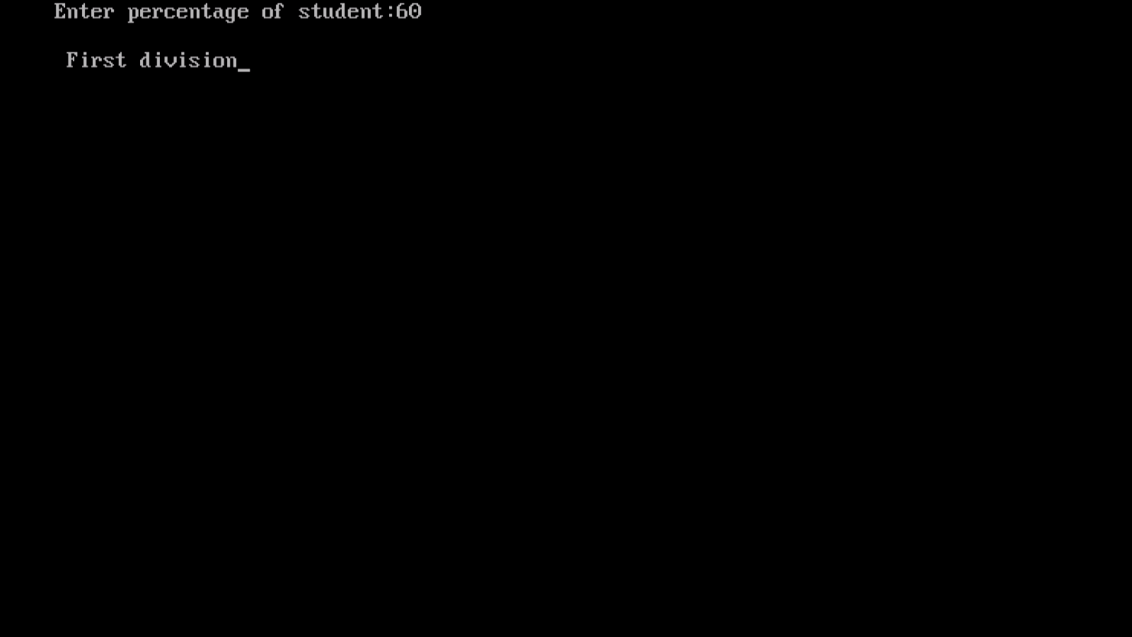

Q.2 Write a program in c to find prime number or not.

Ans.

**Flowchart:-**

Read n

i=2

False

While(i<n)

{

if(n%i==0)

{

f=1;

break;

}

i++;

}

if(f==1)

printf("\n not a prime number");

else

printf("\n prime number");

True

If(n%i==0)

if(n%i==0)

{

f=1;

break;

}

i++;

}

if(f==1)

printf("\n not a prime number");

else

printf("\n prime number");

True

F=1

If(f==1)

false

True

Prime number

Not prime number

**Algorithm:-**

* Start
* Read number
* i=2
* while(i<n)
* if(n%i==0)
* f=1
* if(f==1) then print not prime
* else print prime
* end

**Code:-**

#include<stdio.h>

#include<conio.h>

void main()

{

int n,i,f;

f=0;

printf("Enter a number");

scanf("%d",&n);

i=2;

while(i<n)

{

if(n%i==0)

{

f=1;

break;

}

i++;

}

if(f==1)

printf("\n not a prime number");

else

printf("\n prime number");

}

**Output:-**

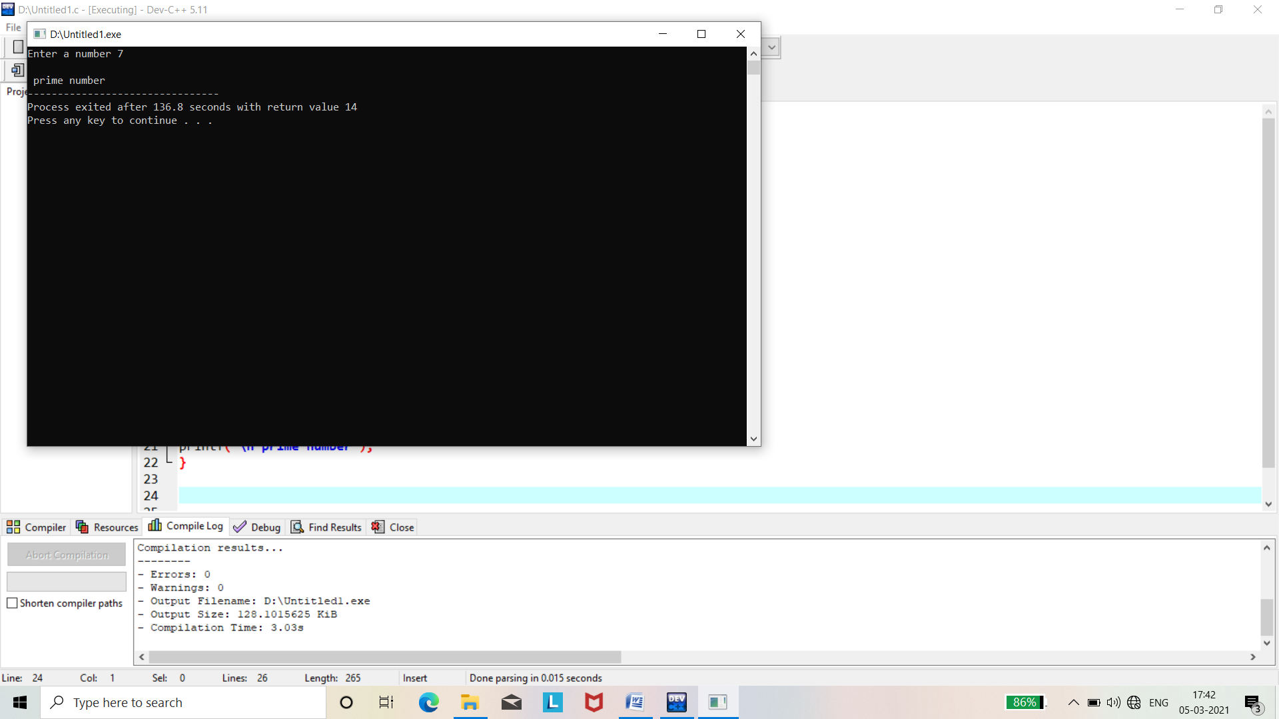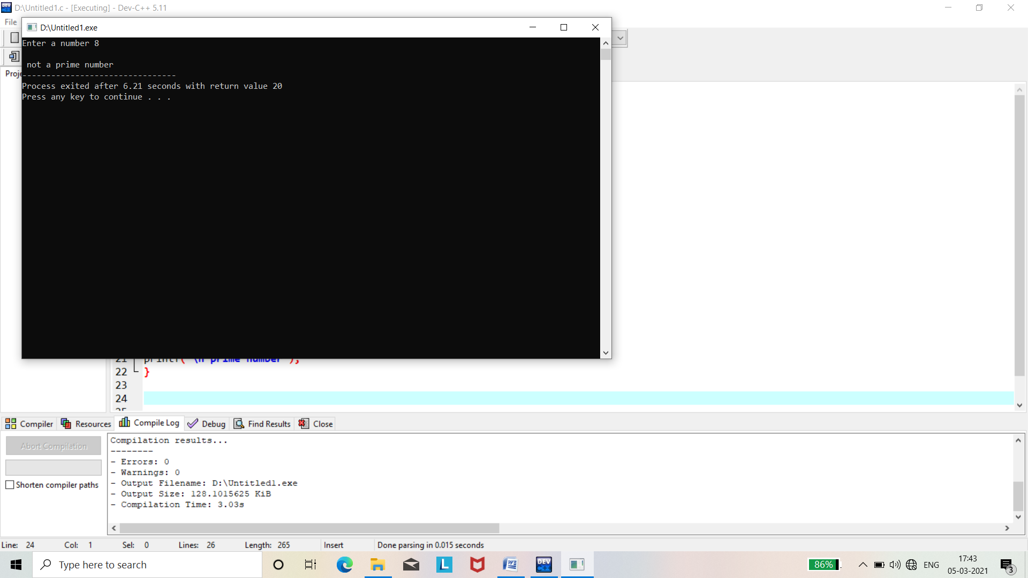

Q.3 Write a program in c to find the leap year.

Ans.

**Algorithm:-**

* start
* year
* if(year%4==0) then leap year
* else not leap year
* stop

***flowchart:-***

**Year**

false

If(year%4==0)

True

Print not leap year

Print leap year

**Code:-**

#include<stdio.h>

#include<conio.h>

int main()

{

int year;

clrscr();

printf("enter the year :");

scanf("%d",&year);

if(year%4==0)

{

printf("the year %d is leap year",year);

}

else

{

printf("the year %d is not leap year",year);

}

return 0;

}

**Output:-**

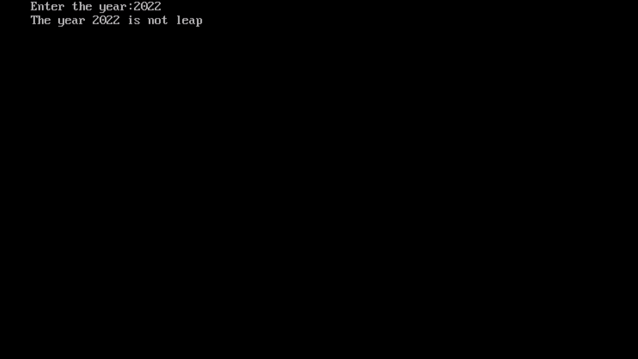

**Q.4**  Write a progran to calculate factorial of a number.

Ans.

**Flowchart:-**

Read n

n>0

false True

erro

F=1

n==1

true

Write fact

f=f*n

n=n+1

**Algorithm:-**

* start
* read n
* if(n>0) then f=1
* if(n==1) then f=f*n and n=n+1
* write fact -stop
* else error
* stop

Code:-

#include<stdio.h>

#include<conio.h>

long int facto(int n)

{

if(n==1)

{

return 1;

}

else return n*facto(n-1);

}

void main()

{

long int f;

int num;

printf("Enter any number :");

scanf("%d",&num);

if(num>0)

{

f=facto(num);

printf("factorial is %d",f);

}

else

{

printf("\n error:given number is %d negative",num);

}

}

Output:-

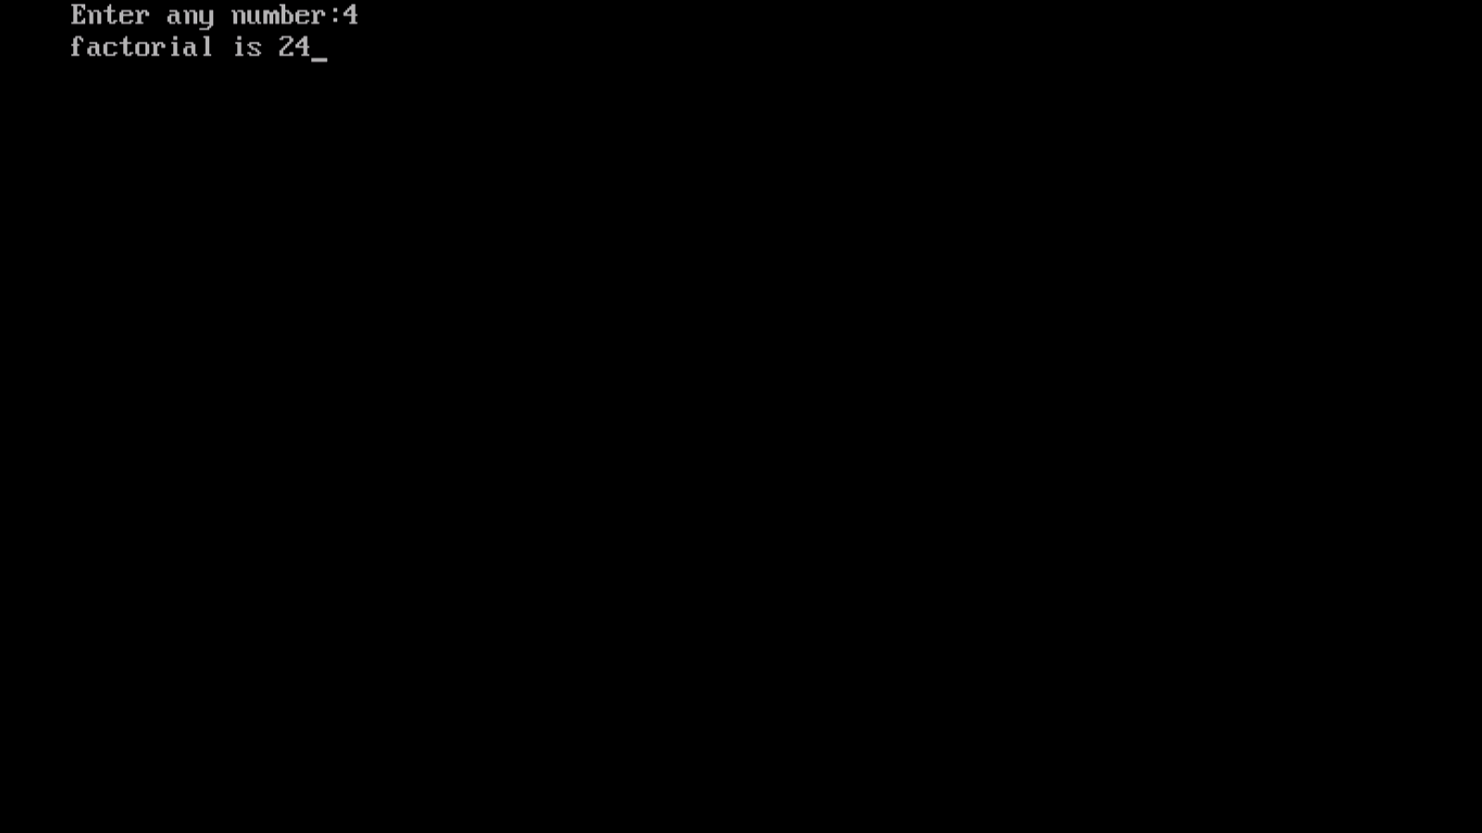

Q. 5 Write a program in c to calculate power using recursion.

Ans.

#include<stdio.h>

#include<conio.h>

long int power(int a,int b)

{

Long int s=1;

Int I;

If(b==0)

{

return 0;

}

for(i=1;i<=b;i++)

{

s=s*a;

}

return s;

}

Void main()

{

long int p;

int c,d;

printf(“Enter any two number\n”);

scanf(“%d%d”,&c,&d);

p=power(c,d);

printf(“\n power is %d”,p);

getch();

}

Output:-

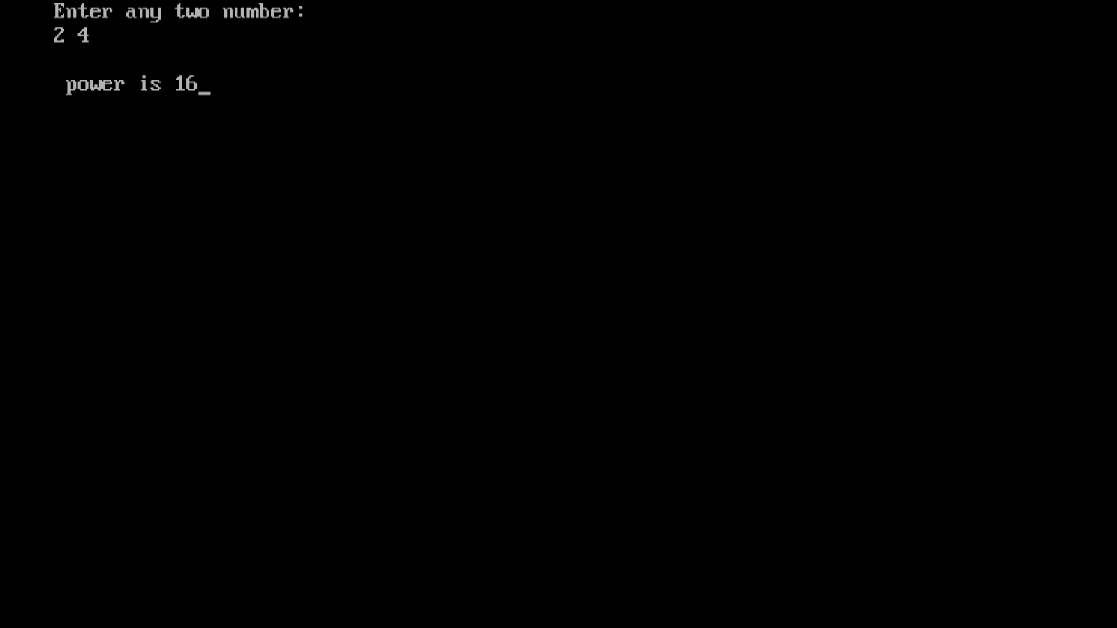

Q.6. Write a program in c to find even or odd numbers.

Ans.

**Flowchart:-**

**input**

If number%2==0

Yes No

Display odd number

Display even number

**Algorithm:-**

* start
* input number
* if(number%2==0) then it is even number
* else odd number
* end

#include<stdio.h>

#include<conio.h>

Void main()

{

Int n,r;

Clrscr();

Printf(“Enter a number:”);

Scanf(“%d”,&n);

r=n%2;

if(r==0)

{

Printf(“Even number”);

}

else

{

Printf(“odd number”);

}

getch();

}

Output:-

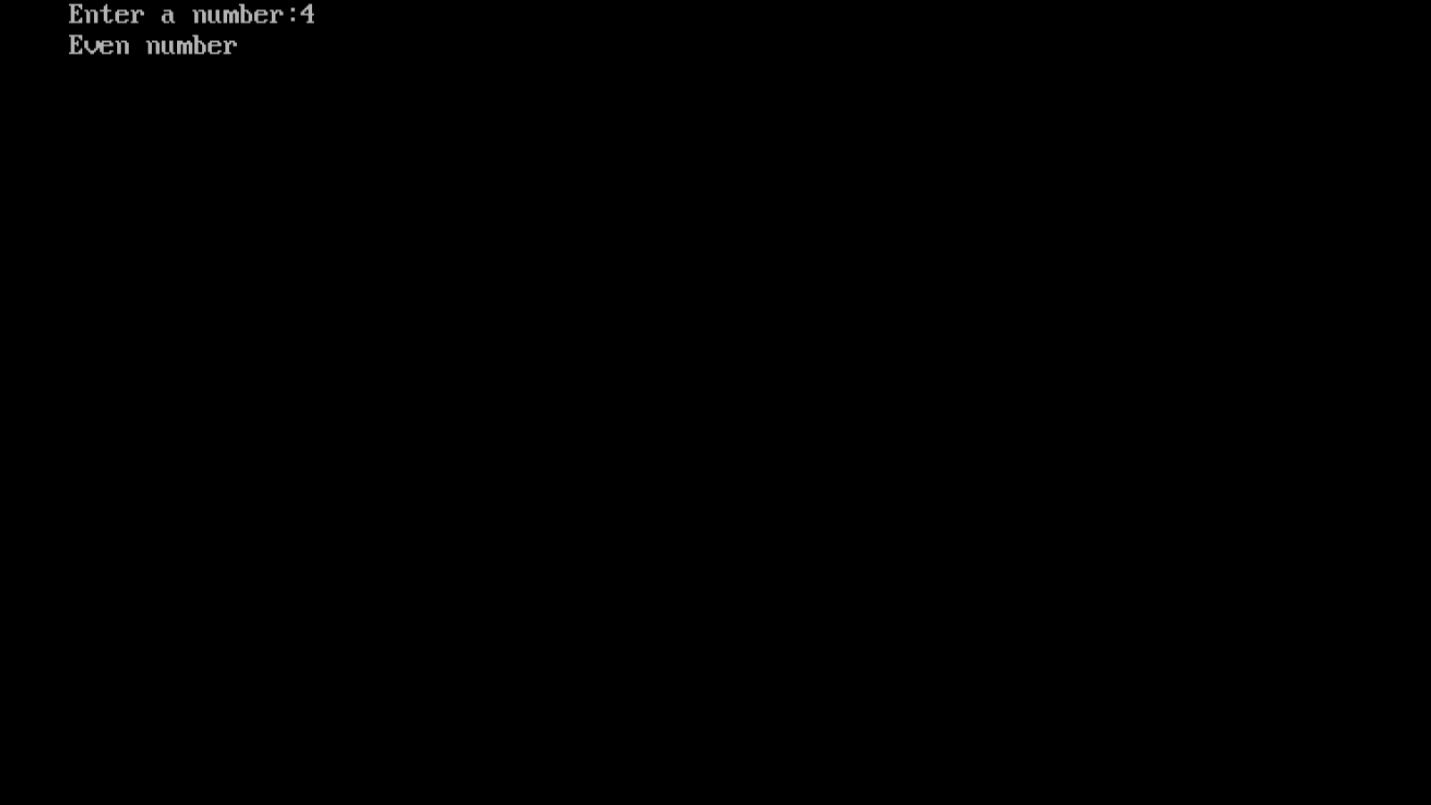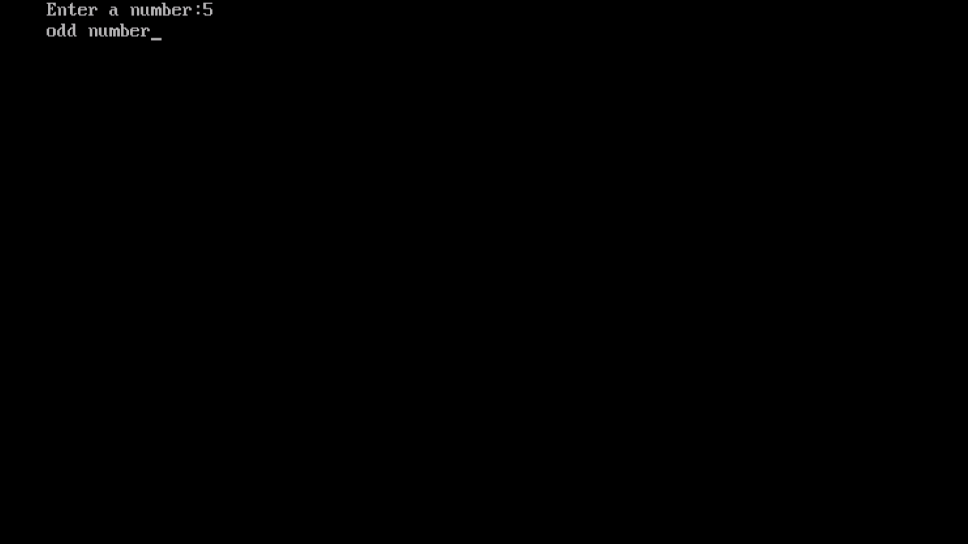

Q.7 Write a program in c to print fabonnaci series.

Ans.

**Flowchart:-**

Declare variable i,n,n1,n2,n3

Initialize n1=0,n2=1 and n3

Input the number of them to be printed

The fabonacci series is :\n\n\n a b

i=2

i<=n

No Yes

n3=n1+n2

n1=n2;

n2=n3, i++

Display n3

-

**Algorithm:-**

* start
* declare variable i,n,n1,n2,n3
* intialize n1=0,n2=1 and n3=0
* input number
* i=2
* check i<=n then n3=n1+n2,n1=n2,n2=n3
* display n3
* stop

**code:-**

#include<stdio.h>

#include<conio.h>

Void main()

{

int i,n,n1=0,n2=1,n3;

Clrscr()

Printf(“Enter the number:”);

Scanf(“%d”,&n);

Printf(“The fibonnaci series :\n”);

Printf(“%d \n”,n2);

for(i=3;i<=n;i++)

{

n3=n1+n2;

printf(“%d \n”,n3);

n1=n2;

n2=n3;

}

getch();

}

Output:-

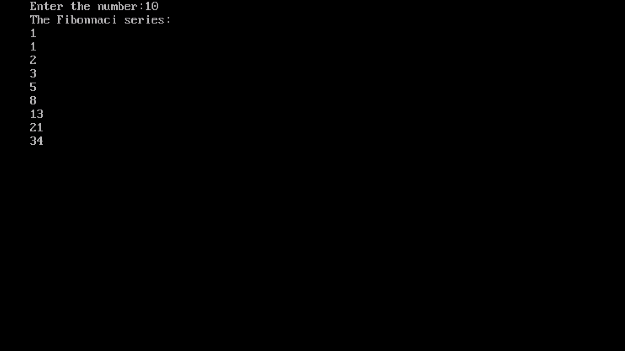

Q.8 Write a Function to check uppercase letter.

Ans.

Flowchart :-

Input number

NO Yes

If(ch>=’A’&&ch<=’Z’)

Display

UPPERCASE CHARACTER

display

not an alphabet

Algorithm:-

* start
* input number
* if(ch>=’A’&&ch<=’Z’) it is true then display UPPERCASE CHARACTER
* else not an alphabet
* end

Code:-

#include<stdio.h>

#include<conio.h>

Void characcheck(char ch)

{

If(ch>=’A’&&ch<=’Z’)

{

Printf(“UPPERCASE CHARACTER\n”);

}

Else

Printf(“is not an alphabet\n”);

}

Int main()

{

char c;

printf(“Enter any character\n”);

scanf(“%c”,&c);

characcheck(c);

getch();

return 0;

}

Output:-

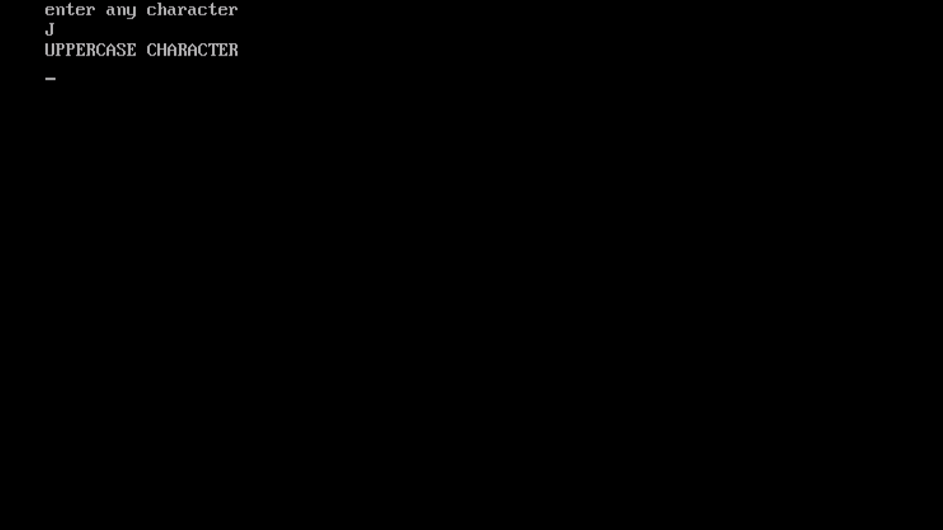

Q.9 Write a program in c to function to check lowercase letter.

Ans.

**Algorithm:-**

* start
* input number
* if(ch>=’a’&&ch<=’z’) it is true then display LOWERCASE CHARACTER.
* else not an alphabet
* end

**Flowchart:-**

Display

LOWERCASE CHARACTER

Input number

If(ch>=’a’&&ch<=’z’)

NO Yes

display

not an alphabet

**Code:-**

#include<stdio.h>

#include<conio.h>

Void characcheck(char ch)

{

If(ch>=’a’&&ch<=’z’)

Printf(“LOWERCASE CHARACTER\n”);

Else

Printf(“is not an alphabet\n”);

}

Int main()

{

char c;

printf(“Enter any character\n”);

scanf(“%c”,&c);

characcheck(c);

getch();

return 0;

}

Output:-

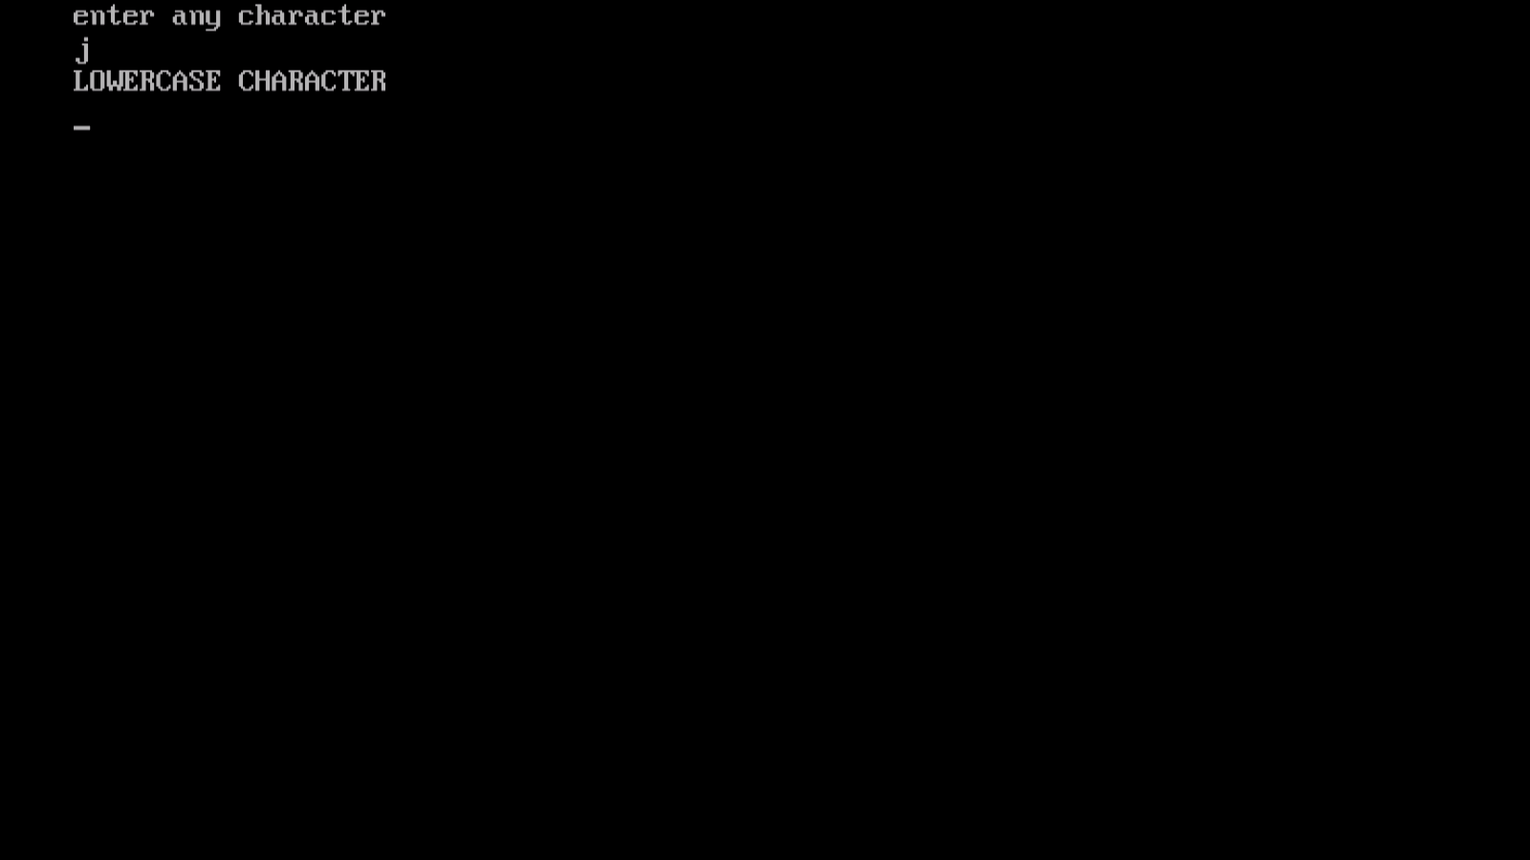

Q,10 Find the greater of the three numbers

Ans.

**Flowchart:-**

Input number

If(n1>=n2&&n1>n3)

Yes No

Display n1 largest

Yes No

If(n2>=n3)

Display n3 largest

Display n2 largest

**Algorithm:-**

* **start**
* **input numbers**
* **check condition if(n1>=n2&&n1>=n3) it is true then display n1 largest**
* **if(**

**Code:-**

#include<stdio.h>

#include<conio.h>

Int main()

{

Int n1,n2,n3;

Printf(“Enter three numbers:”);

Scanf(“%d%d%d”,&n1,&n2,&n3);

If(n1>=n2)

{

If(n1>=n3)

Printf(“\n n1 largest”);

else

printf(“\n n3 largest”);

}

else

{

If(n2>=n3)

Printf(“\n n2 largest”,n2);

else

{

Printf(“\n n3 largest”,n3);

}

return 0;

}

Output:-

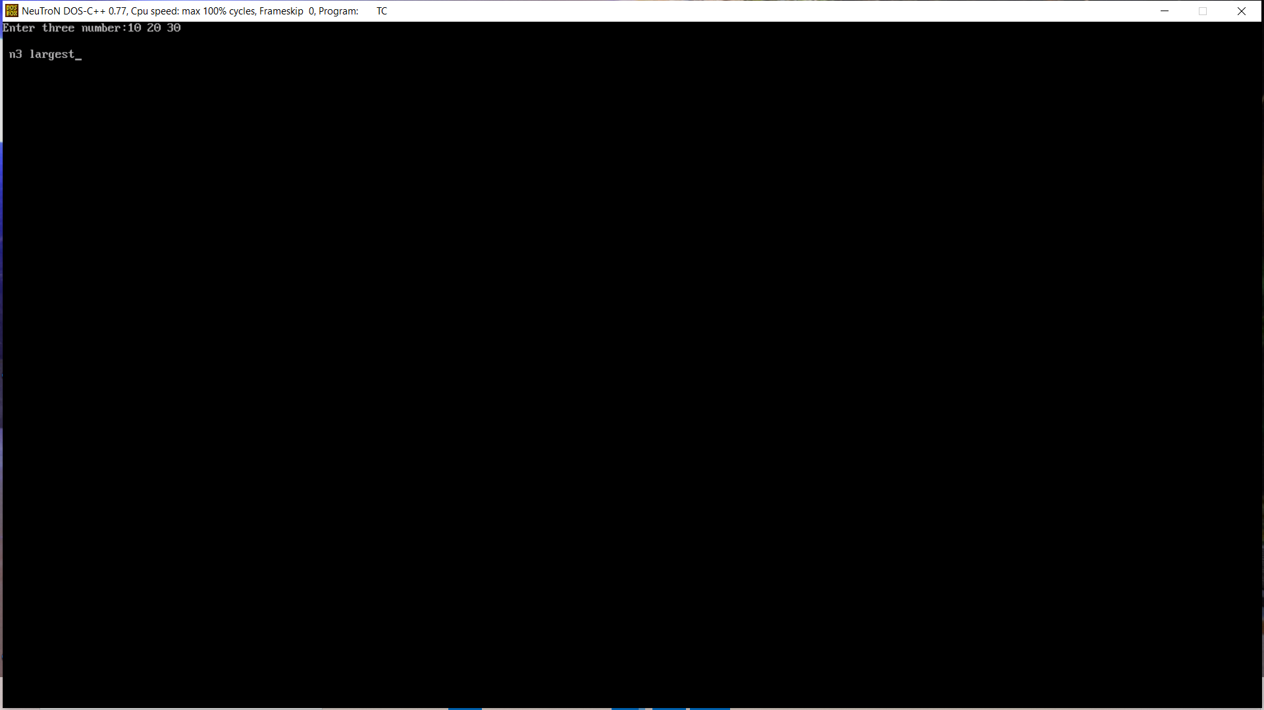

Q.11 Write a program in c to type casting implicit explicit.

Ans.

#include<stdio.h>

#include<conio.h>

Void main()

{

Int x=10;

Float y=10.4;

Int z;

Float w;

z=x+y;//implicit

w=(float)x+y;// explicit

printf(“%d\n”,z);

printf(“%f”,w);

getch();

}

Output:-

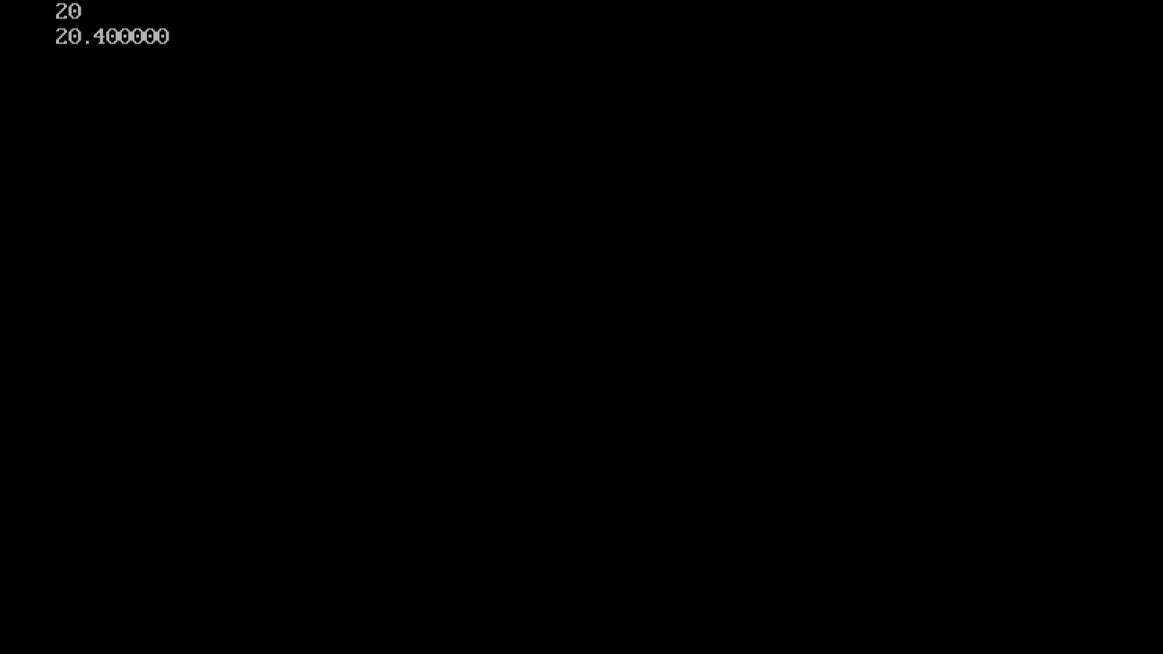

Q.12 Write program to display number 1 to 10 in octal, decimal and hexadecimal system.

Ans.

#include<stdio.h>

#include<conio.h>

void main()

{

Int I;

Clrscr();

Printf(“\n This program is to print 1 to 10 numbers in different number system.\n\n”);

Printf(“\n |---------------------------------|--------------------------- |---------------------------------------|”);

Printf(“\n | Decimal number system|octal number system|hexadecimal number system|”);

for(i=1;i<=10;i++)

{

Printf(“\n| %d | %o | %x |”,i,I,i);

}

Printf(“\n|------------------------|----------------------------|-------------------------|”);

Getch();

}

Output:-

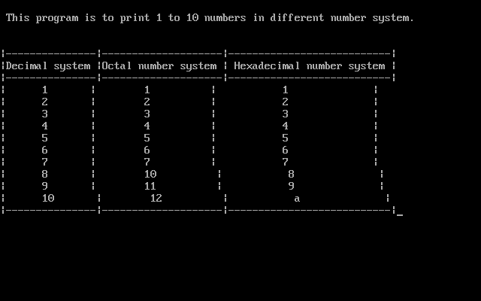

Q.13 write program to generate following pattern

a)

ABCDEFG

ABC EFG

AB FG

A G

Ans.

#include<stdio.h>

#include<conio.h>

Void main()

{

Char c;

Clrscr();

for(c=’A’;c<=’G’;c++)

{

printf(“ %c ”,c);

}

printf(“\n”);

for(c=’A’;c<=’G’;c++)

{

If(c==’D’)

{

printf(“ ”,c);continue;}

printf(“ %c ”,c);

}

printf(“\n”);

for(c=’A’;c<=’G’;c++)

{

If(c>=’C’&&c<=’E’)

{

printf(“ ”,c);continue;}

printf(“ %c ”,c);

}

Printf(“\n”);

For(c=’A’;c<=’G’;c++)

{

If(c>=’B’&&c<=’F’)

{

printf(“ ”,c);continue;}

printf(“ %c ”,c);

}

printf(“\n\n”);

getch();

}

Output

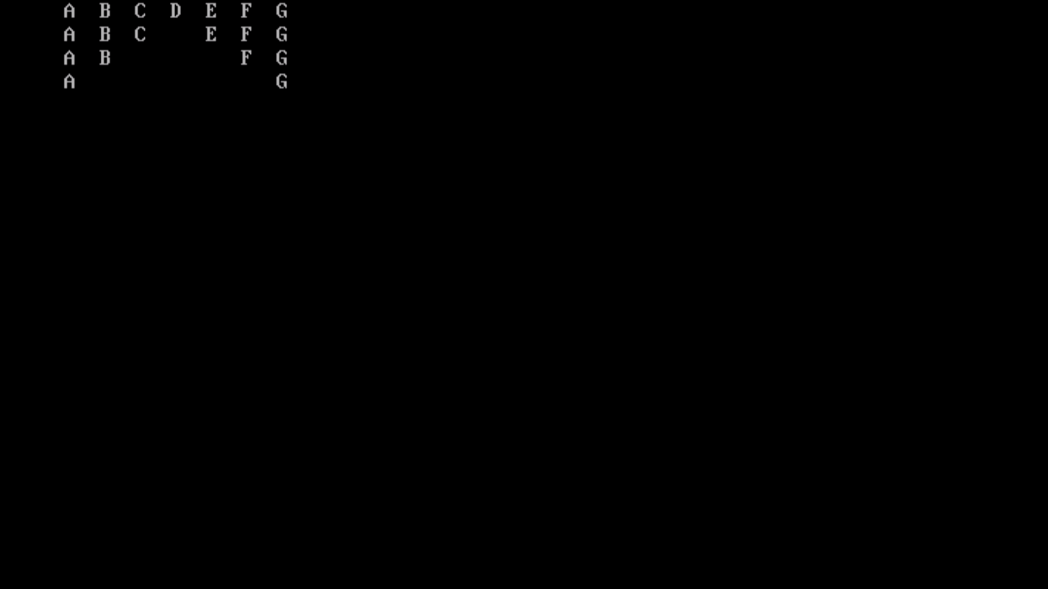

b).

1

1 2

1 2 3

1 2 3 4

Ans.

#include<stdio.h>

#include<conio.h>

Void main()

{

Int I,j;

Clrscr();

for(i=1;i<=4;i++)

{

for(j=1;j<=i;j++)

{

printf(“ %d”,j);

}

printf(“\n”);

}

getch();

}

Output :-

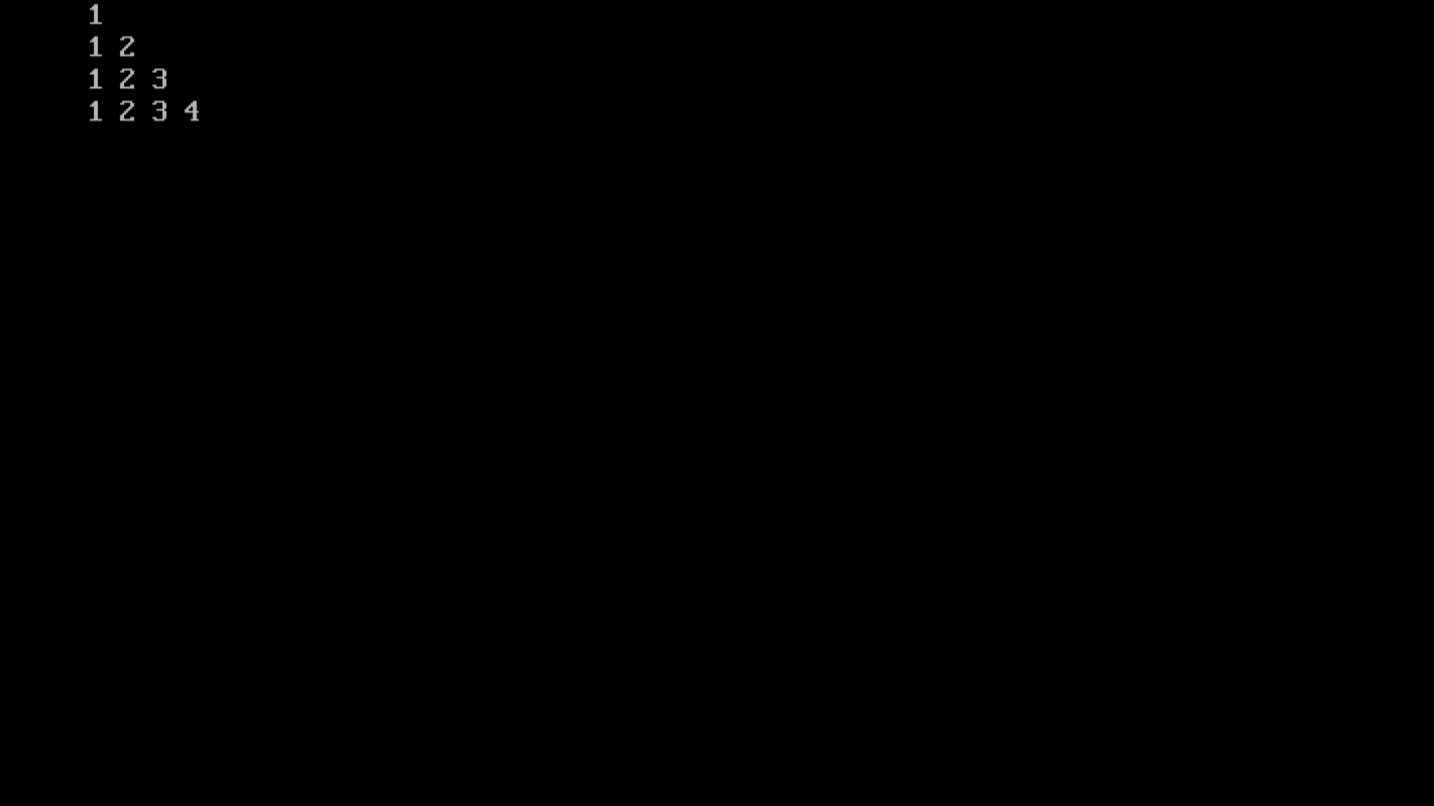

c).

*

* *

* * *

Ans.

# include<stdio.h>

# include<conio.h>

Void main( )

{

Int n;

Int r,j,k;

Clrscr ( );

Printf(“Enter the number of rows\n”);

Scanf(“%d”,&n);

for(r=1;r<=n;r++){

for(j=n-r;j>=1;j--){

printf(“ “)

}

for(k=1;k<=r;k++){

printf(“* ”);

}

Printf(“\n”);

}

getch( );

}

Output:-

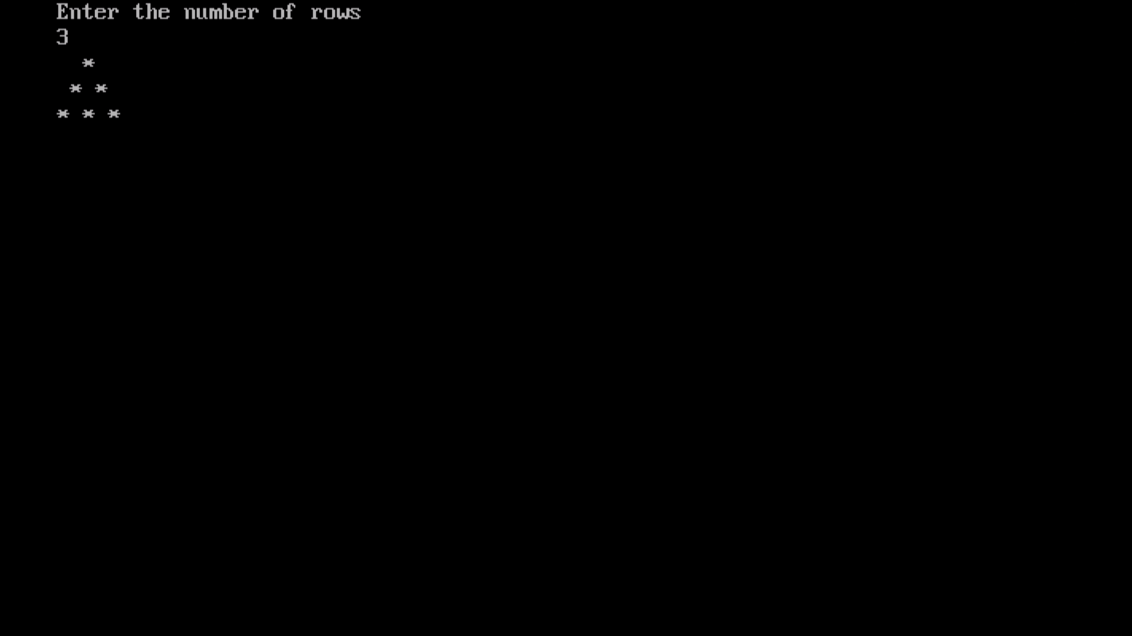

d).

1

1 1

1 2 1

1 3 3 1

1 4 6 4 1

#include<stdio.h>

#include<conio.h>

void main()

{

Clrscr();

Int row,col,space,n,no;

Printf(“enter any number:”)

Scanf(“%d”,&no)

for(row=0;row<no;row++)

{

{

printf(“”);

}

n=1; for(col=0;col<=row;col++) {

printf(“%d”,n);

n=n*(row-col)/(col+1);

}

printf(“\n”);

}

getch();

}

Output:-

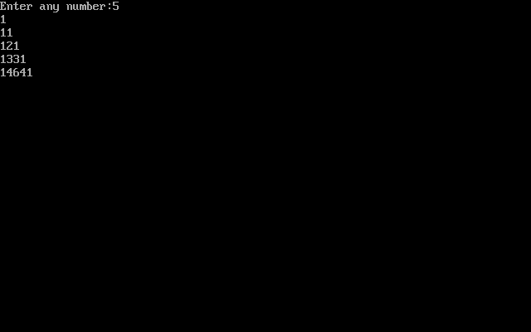

Q.14 Write a program to input from user (5 subjects) sum,average.

Ans.

#include<stdio.h>

#include<conio.h>

Void main()

{

Int marks,sub,count,sum=0;

Float avg=0.0;

Printf(“Enter number of subjets\n”);

Scanf(“%d”,&sub);

Printf(“Enter %d Subjects marks\n”,sub);

For(count=1;count<=sub;count++)

{

Scanf(“%d”&marks);

Sum=sum+marks;

}

Avg=sum/sub;

Printf(“sum=%d\nAverage =%0.2f\n”,sum,avg);

getch();

}

Output:-

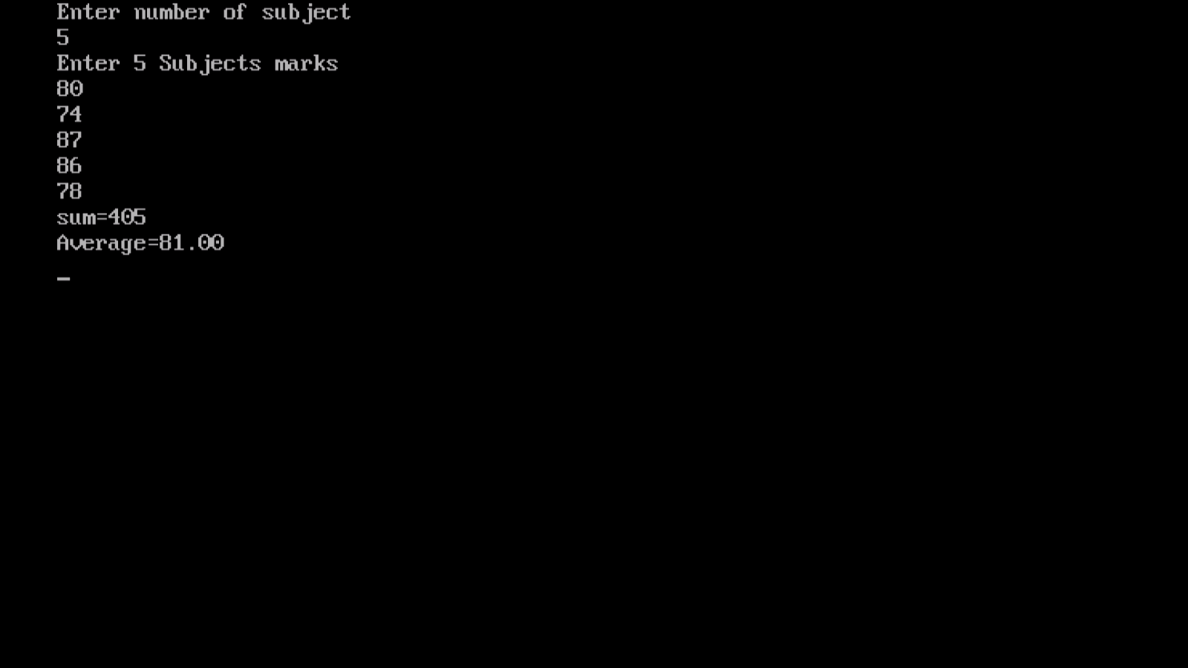

Q.15 Write a program to print student marksheet.

Ans.

#include<stdio.h>

#include<conio.h>

Sturct student

{

Char name[50];

Int marks[5];

Long int rollno;

};

Int main()

{

Clrscr();

Struct student a;

Int i,sum=0,per;

Printf(“Enter student name:”);

Gets(a.name);

Printf(“\nEnter student roll no.:”);

Scanf(“%d”,&a.rollno);

Printf(“\n Enter student marks\n”);

For(i=0;i<5;i++)

{

Printf(“\n Enter %d subject marks:”i+1);

Scanf(“%d”,&a.marks[i]);

}

For(i=0;i<5;i++)

Sum=sum+a.marks[i];

Per=sum/5;

Clrscr();

Printf(“\n STUDENT NAME :%s”,a.name);

Printf(“\n STUDENT ROLL NO. :%ld”,a.rollno);

Printf(“\n OBTAINED MARKS :500”);

Printf(“\n TOTAL MARKS :%d”,sum);

Printf(“\n PERCENTAGE :%d”,per);

Printf(“\n DIVISION : ”);

if(per>100)

{

Printf(“\n invalid percent”);

}

else if(per>=60)

{

Printf(“\n first division”);

}

else if(per<60&&per>=50) {

printf(“second division”);

}

else if(per<50&&per>=40) {

printf(“\m third division”);

}

else

{

Printf(“\n You are fail”);

}

getch();

return 0;

}

Output:-

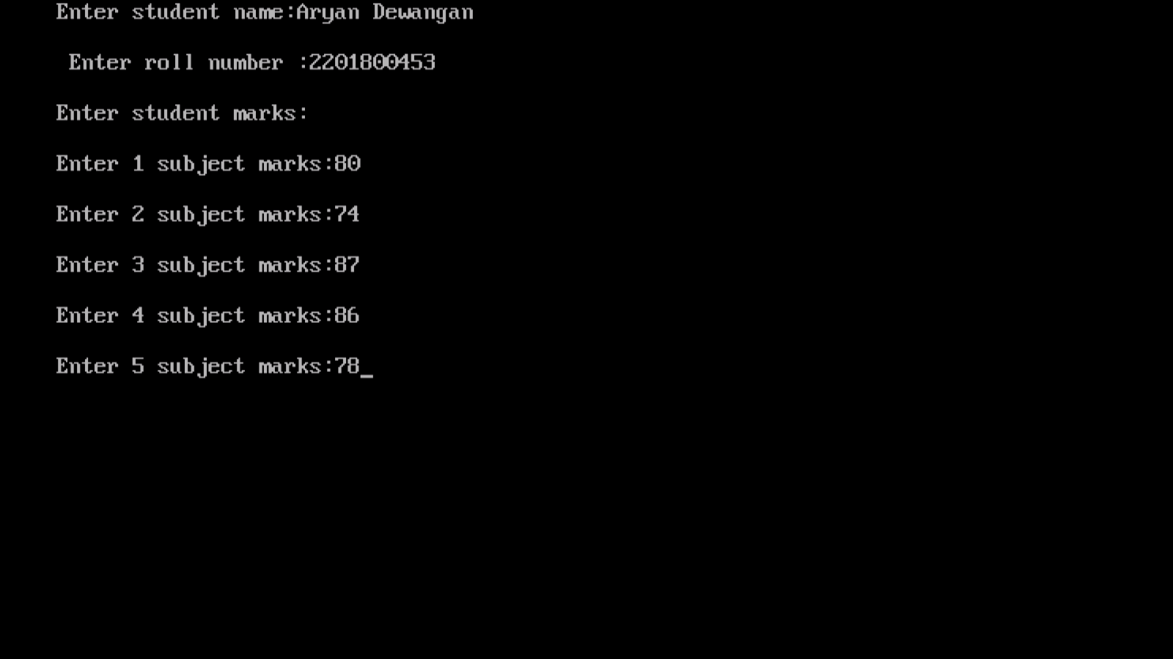

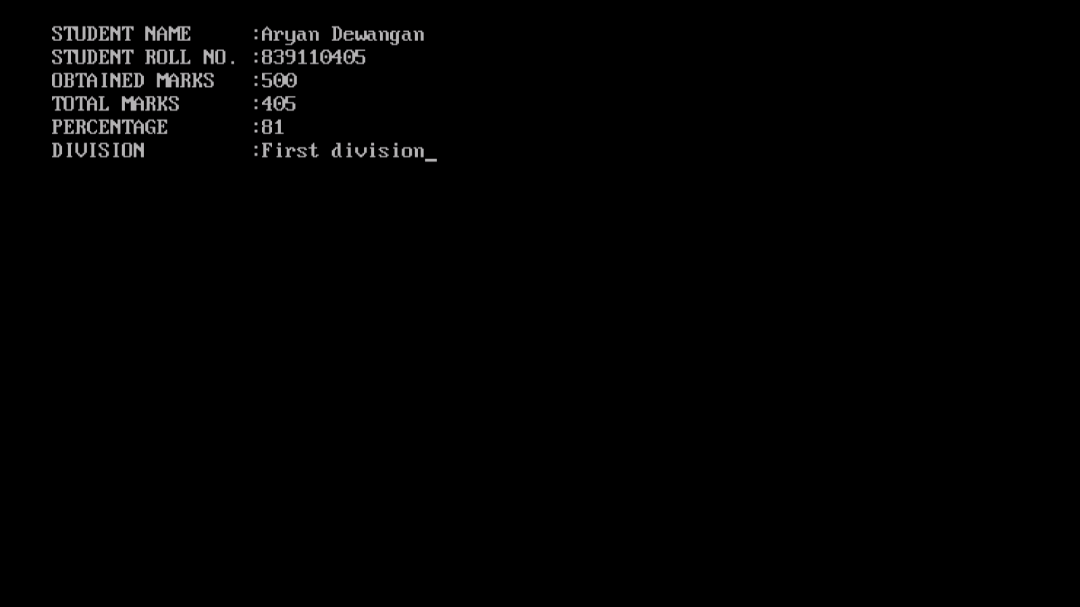

Q16. Write a program to calculate simple interest.

Ans.

#include<stdio.h>

#include<conio.h>

Void main()

{

float amt,rate,time,si;

clrscr();

printf(“Enter the amount:”);

scanf(“%f”,&amt);

printf(“Enter the rate:”);

scanf(“%f”,&rate);

printf(“Enter the time:”);

scanf(“%f”,&time);

si=(amt*rate*time/100);

printf(“\nSimple interest= %f”,si);

getch();

}

Output:-

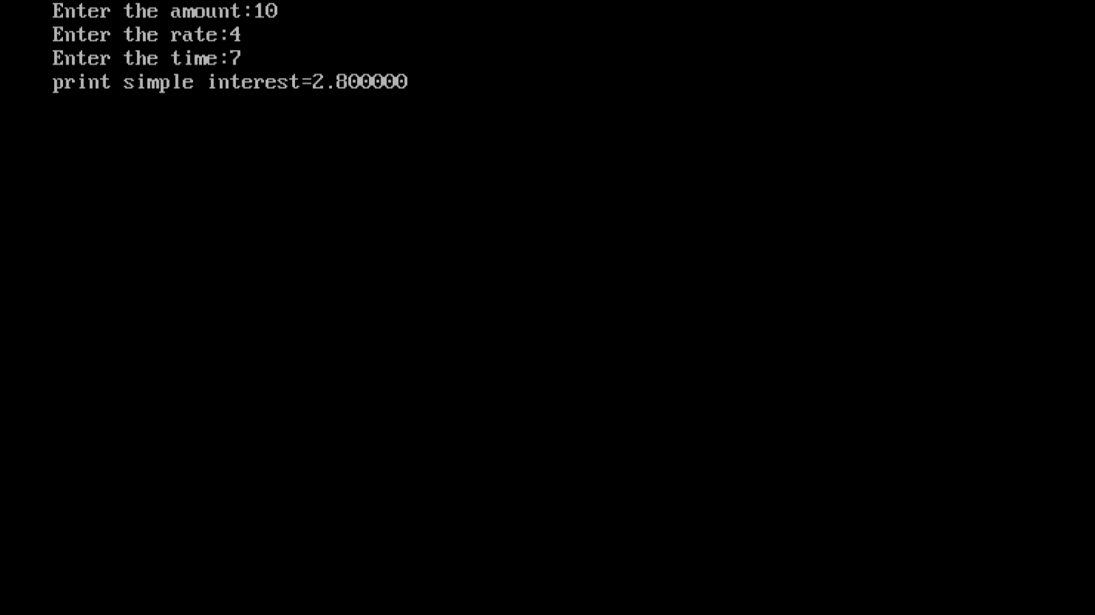

Q.17 Write a program in which you declare variable of all data types supported by C language. Get input from user and print the value of each variable with alignment left, right and column width 10. For real numbers print their values with two digits right to the decimal.

Ans.

#include<stdio.h>

#include<conio.h>

void main() {

char c;

int i;

float f;

double k;

printf("Enter any character:");

scanf("%c",&c);

printf("\n Enter any number i=");

scanf("%d",&i);

printf("\n Enter any real no. f=");

scanf("%f",&f);

printf("\n Enter any double float value k=");

scanf("%lf",&k);

printf("\n %10c",c);

printf("\n %010d",i);

printf("\n %.2f",f);

printf("\n %10.2lf",k);

getch();

}

Output:-

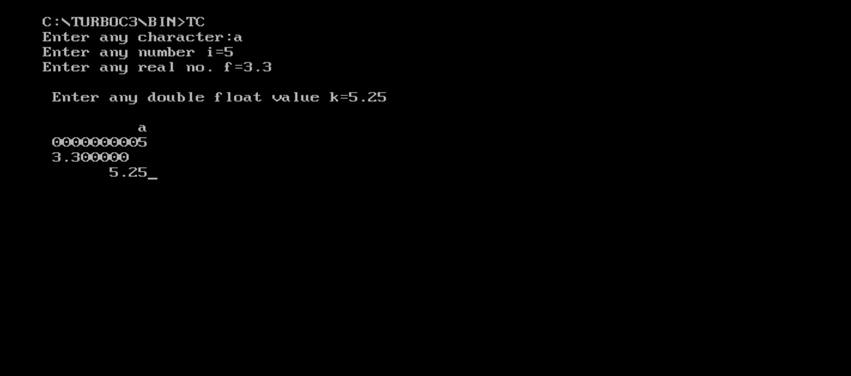

Q.18. Write a program to demonstrate multiplication table input from user till 10.

Ans.

#include<stdio.h>

#include<conio.h>

Void main()

{

Int n,I;

Clrscr();

Printf(“Enter any no:”);

Scanf(“%d”,&n);

Printf(“Multiplication table of %d\n”,n);

For(i=1;i<=10;i++)

{

Printf(“%d*%d=%d\n”,n,I,(n*i));

}

getch();

}

Output:-

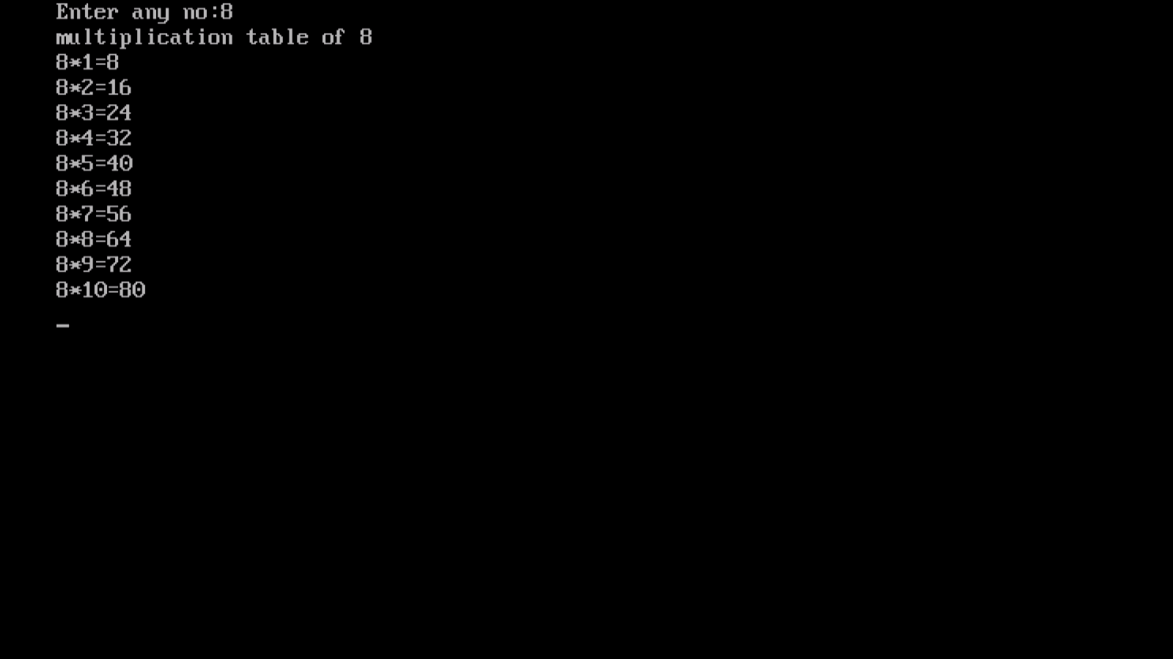

Q. 19. Write a program to demonstrate addition of two matrix.

Ans.

#include<stdio.h>

#include<conio.h>

Void main()

{

Int a[3][3],b[3][3],c[3][3],I,j;

Clrscr();

Printf(“enter the element of the first matrix\n”);

For(i=0;i<3;i++)

{

For(j=0;j<3;j++)

{

Scanf(“%d”,&a[i][j]);

}

}

Printf(“enter the element of second matrix\n”);

For(i=0;i<3;i++)

{

For(j=0;j<3;j++)

{

Scanf(“%d”,&a[i][j]);

}

}

Printf(“The first matrix is\n”);

For(i=0;i<3;i++)

{

For(j=0;j<3;j++)

{

printf(“%d\t”,&a[i][j]);

}

Printf(“\n”);

}

Printf(“The second matrix is\n”);

For(i=0;i<3;i++)

{

For(j=0;j<3;j++)

{

printf(“%d\t”,&b[i][j]);

}

Printf(“\n”);

}

For(i=0;i<3;i++)

{

For(j=0;j<3;j++)

{

C[i][j]=a[i][j]+b[i][j];

}

}

Printf(“The addition of two matrix\n”);

For(i=0;i<3;i++)

{

For(j=0;j<3;j++)

{

printf(“%d\t”,c[i][j]);

}

Printf(“\n”);

}

getch();

}

Output:-

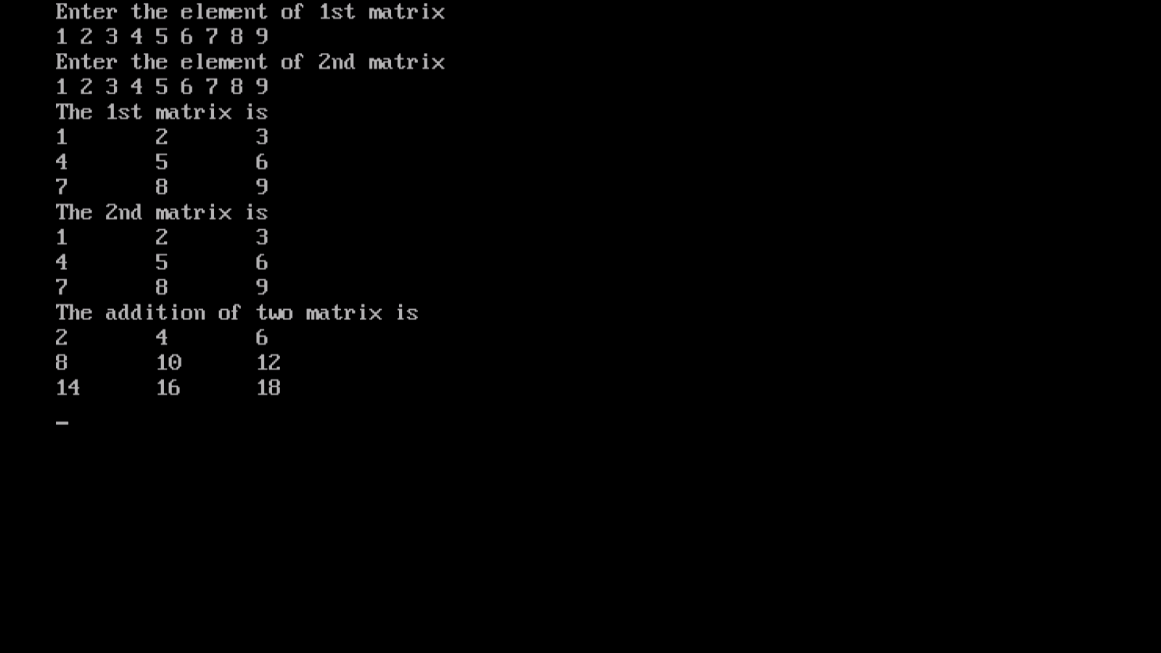

Q.20. Write a program to multiplication of two matrix.

Ans.

#include<stdio.h>

#include<conio.h>

Void main()

{

Int a[3][3],b[3][3],c[3][3],I,j,k;

Clrscr();

Printf(“enter the element of the first matrix\n”);

For(i=0;i<3;i++)

For(j=0;j<3;j++)

Scanf(“%d”,&a[i][j]);

Printf(“enter the element of second matrix\n”);

For(i=0;i<3;i++)

For(j=0;j<3;j++)

Scanf(“%d”,&a[i][j]);

Printf(“The first matrix is\n”);

For(i=0;i<3;i++)

{

For(j=0;j<3;j++)

{

printf(“%d\t”,&a[i][j]);

}

Printf(“\n”);

}

Printf(“The second matrix is\n”);

For(i=0;i<3;i++)

{

For(j=0;j<3;j++)

{

printf(“%d\t”,&b[i][j]);

}

Printf(“\n”);

}

For(i=0;i<3;i++)

{

For(j=0;j<3;j++)

{

C[i][j]=0;

For(k=0;k<3;k++)

{

C[i][j]=c[i][j]+a[i][k]*b[k][j];

}

}

}

printf(“Multiplication of two matrix\n”);

for(i=0;i<3;i++)

{

for(j=0;j<3;j++)

printf(“%d\t”,c[i][j]);

Printf(“\n”);

}

getch();

}

Output:-

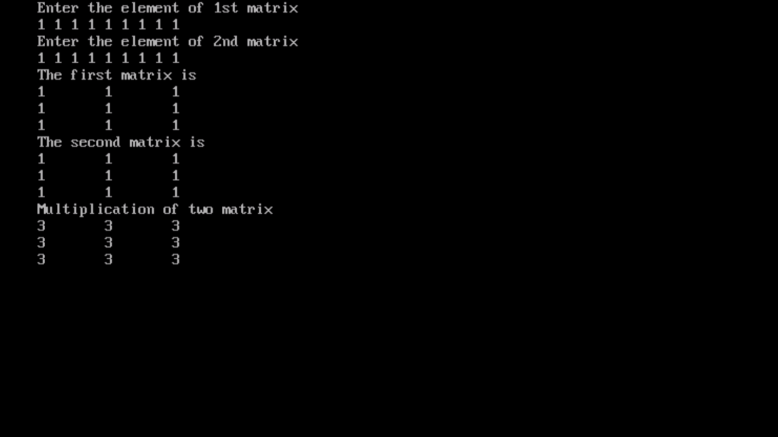

Q.21 Write a program to get input from user and check matrix then matrix multiplication or print not matrix.

Ans.

#include<stdio.h>

#include<conio.h>

#include<stdlib.h>

Void main()

{

Int a[2][2],b[2][2],c[2][2];

Int r1,c1,r2, c2,i,j,k,;

Printf(“Enter the row and column of 1st matrix\n”);

Scanf(“%d%d”,&r1,&c1);

Printf(“Enter the row and column of 2nd matrix\n”);

Scanf(“%d%d”&r2,&c2);

If(c1!=r2)

{

Printf(“\n Matrices are not multiplicable”);

Exit(0);

}

Printf(“\n Enter the element of first matrix\n”);

for(i=0;i<r1;r++)

{

for(j=0;j<c1;j++)

{

Scanf(“%d”,a[i][j]);

}

}

printf(“\n enter the element of second matrix\n”);

for(i=0;r<r2;i++)

{

for(j=0;j<c2;j++)

{

Scanf(“%d”,&b[i][j]);

}

}

printf(“The first matrix is\n”);

for(i=0;i<r1;i++)

{

for(j=0;j<c1;j++)

{

printf(“%d\t”,a[i][j]);

}

printf(“\n”);

}

printf(“The second matrix is\n”);

for(i=0;i<r2;i++)

{

for(j=0;j<c2;j++)

{

printf(“%d\t”,b[i][j]);

}

printf(“\n”);

}

for(i=0;i<r1;i++)

{

for(j=0;j<c2;j++)

{

S=0;

for(k=0;k<c1;k++)

{

s=s+a[i][k]*b[k][j];

c[i][j]=s;

}  
}

}

printf(“Multiplication of two matrix\n”);

for(i=0;i<r1;i++)

{

for(j=0;j<c2;j++)

printf(“%d\t”,c[i][j]);

printf(“\n”);

}

getch();

}

Output:-

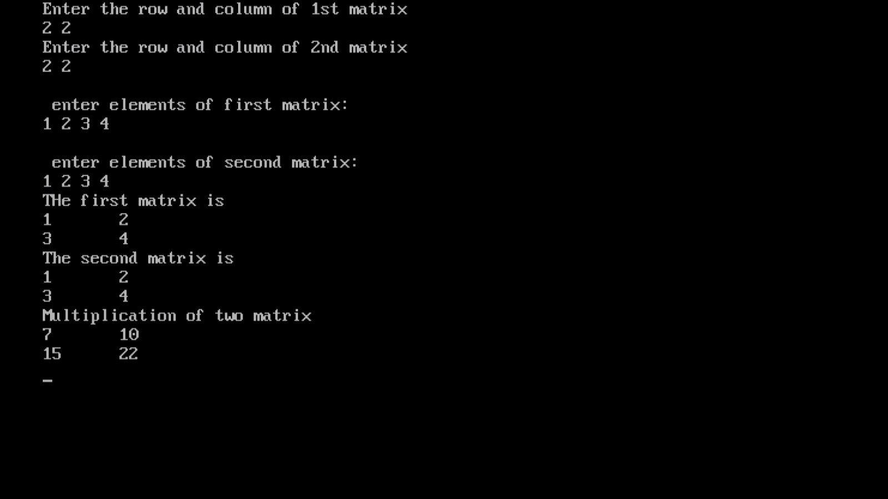

Q. 22 Write a program to print compare two numbers using ternary operators.

Ans.

#include<stdio.h>

#include<conio.h>

void main()

{

Int a,b,c;

printf(“enter two number”);

scanf(“%d”,&a,&b);

c=((a>b)?a:b);

printf(“%d is greater”,c);

getch();

}

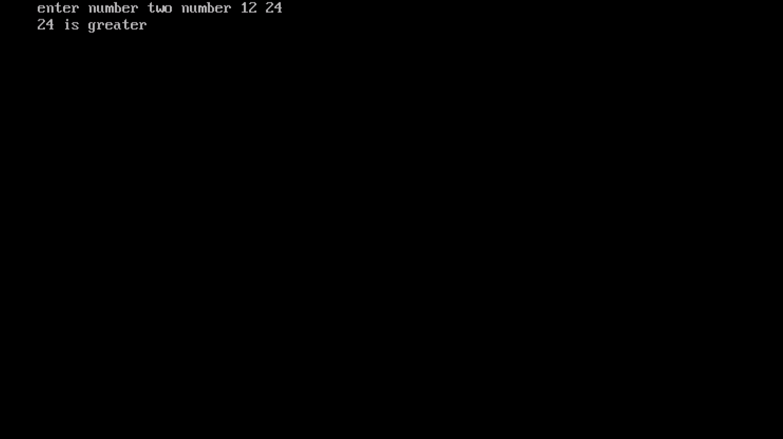

Q.23. Write a program to convert temperature from centigrate to farenhiet.

Ans.

#include<stdio.h>

#include<conio.h>

void main()

{

float c,f;

printf(“\n Enter temperature in centigrate:”);

scanf(“%d”,&c);

f=(c*9/5)+32;

printf(“\n Temp in fah=%f”,f);

getch();

}

Output:-

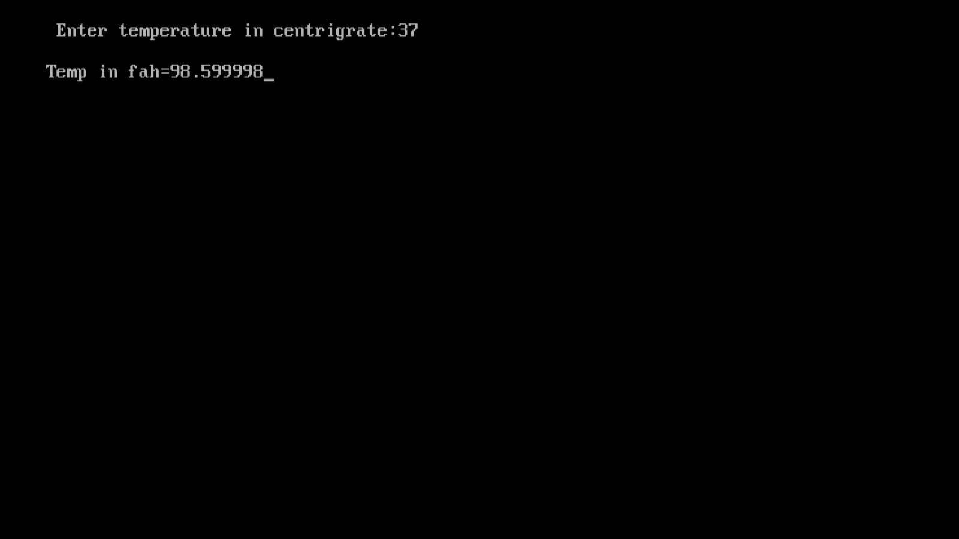

Q.24 Write a program to demonstrate betwise operator left shift and right shift operator.

Ans.

#include<stdio.h>

#include<conio.h>

void main()

{

Int a=4,c;

c=a<<1;

printf(“%d”,c);

c=a>>1;

printf(“%d”,c);

getch();

}

Output:-

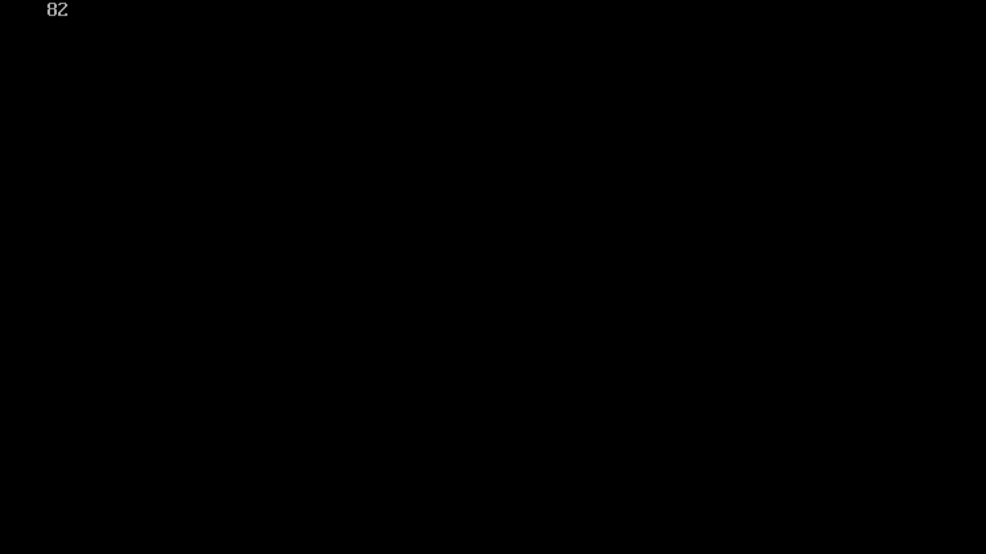

Q.25 Write a program to demonstrate print to increament and decreament operator.

Ans.

#include<stdio.h>

#include<conio.h>

Void main()

{

int x=5;

clrscr();

x++; //post increment operator

printf(“x=%d”,x);

++x; //pre increment operator

printf(“x=%d”,x);

x--; //post decrement operator

printf(“x=%d”,x);

--x; //pre decrement operator

printf(“x=%d”,x);

getch();

}

Output:-

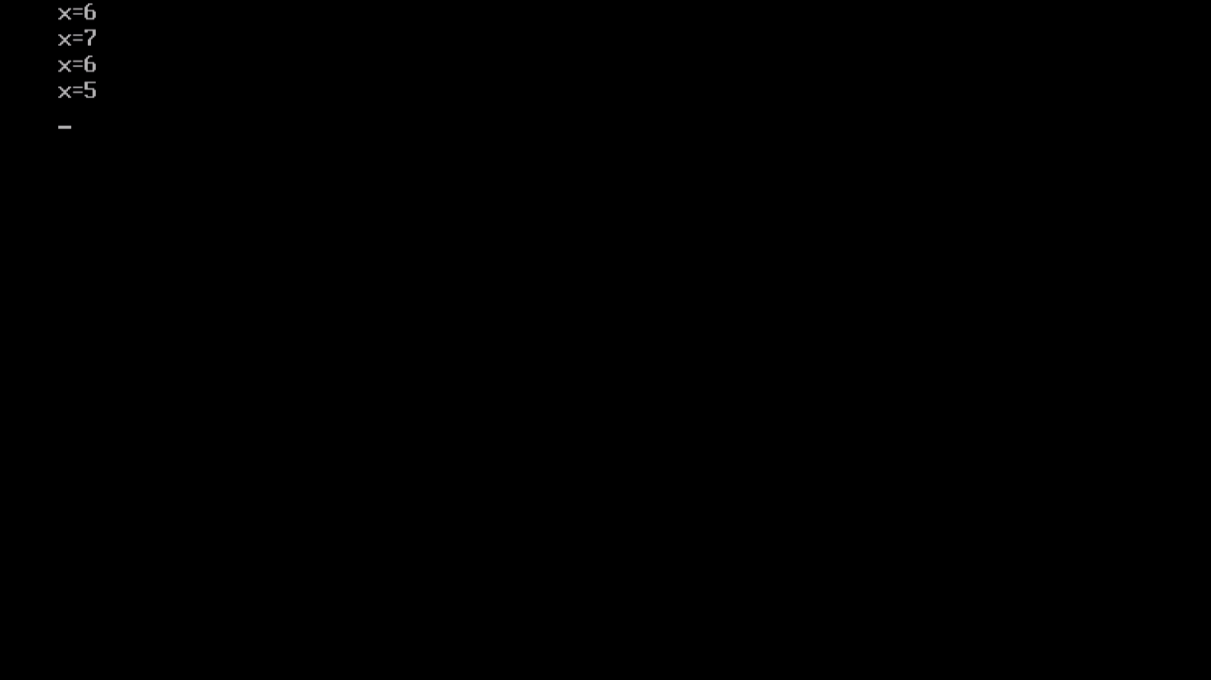

Q. 26. Write a program to calculation of sum of the digit.

Ans.

#include<stdio.h>

#include<conio.h>

Void main()

{

int n,r,sum=0;

printf(“enter a number\n”);

scanf(“%d”,&n);

while(n>0)

{

r=n%10;

sum=sum+r;

n=n/10;

}

printf(“sum of digit of entered number %d”,sum);

getch();

}

Output:

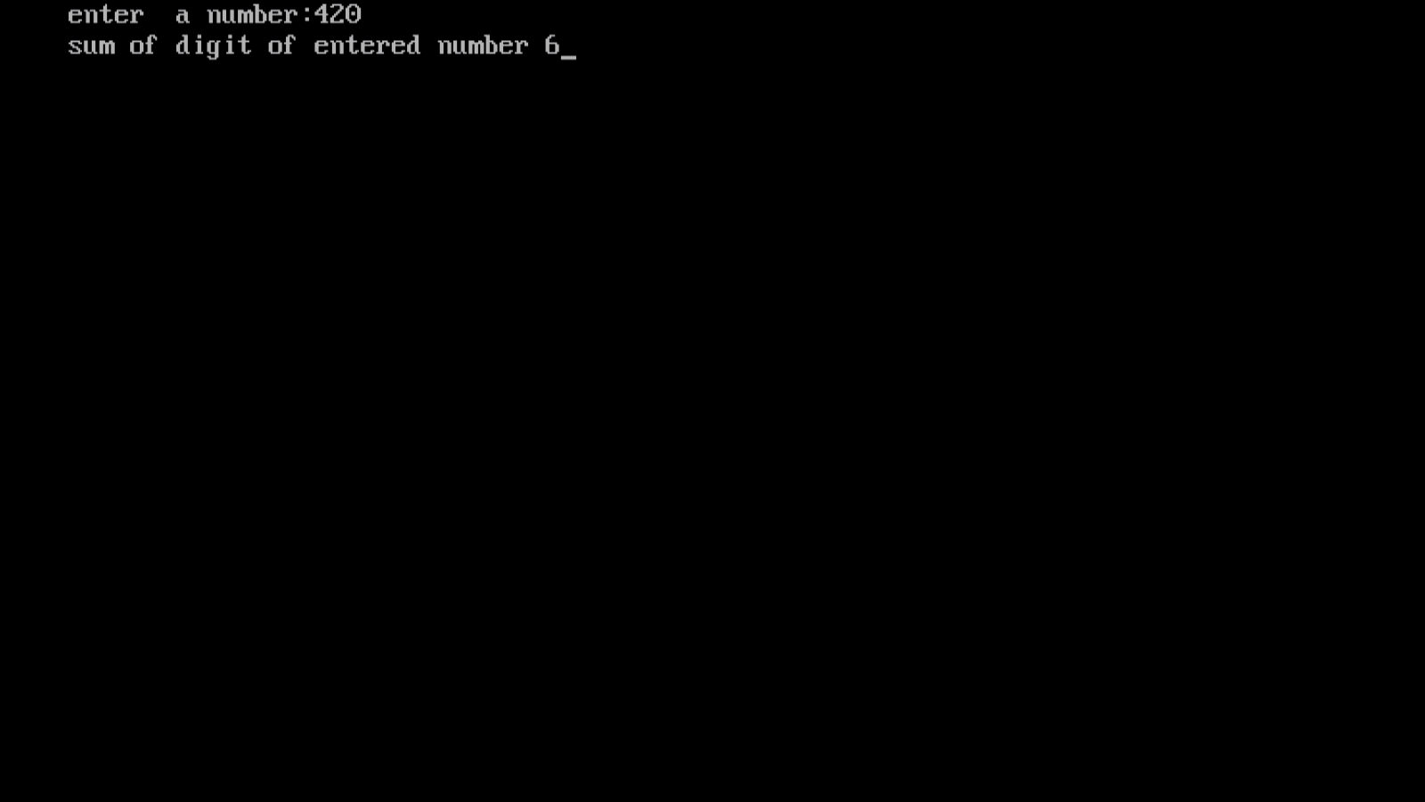

Q.27 Write a program to reverse a string without using library function.

Ans.

#include<stdio.h>

#include<conio.h>

Void main()

{

char a[15],temp;

int I,j,l=o;

clrscr();

printf(“enter the string :”);

scanf(“%s”,a);

for(i=0;a[i]!=’\0’;i++)

l++;

i=0;

j=l-1;

while(i<j)

{

temp=a[i];

a[i]=a[j];

a[j]=temp;

i++;

j++;

}

printf(“reverse string =%s”,a);

getch();

}

Output:-

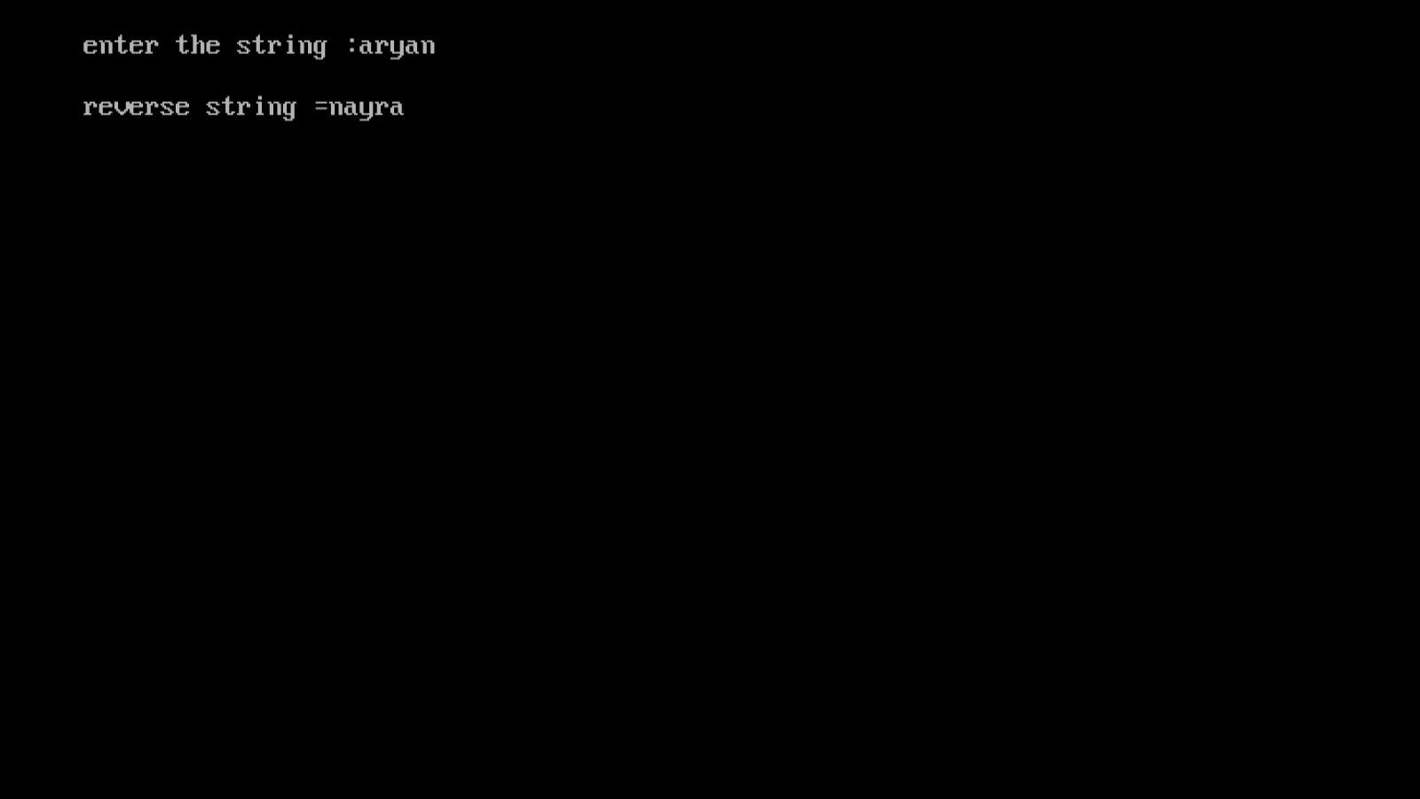

Q.28 Write a program to demonstrate Call by value.

Ans.

#include<stdio.h>

#include<conio.h>

void add(int a);

void main()

{

int x;

printf(“enter any number”);

scanf(“%d”,&x);

add(x);

printf(“\n after calling function variable value is %d”,x);

getch();

}

Void add(int a)

{

a=a+10;

printf(“\n in Called function variable value is %d”,a);

}

Output:-

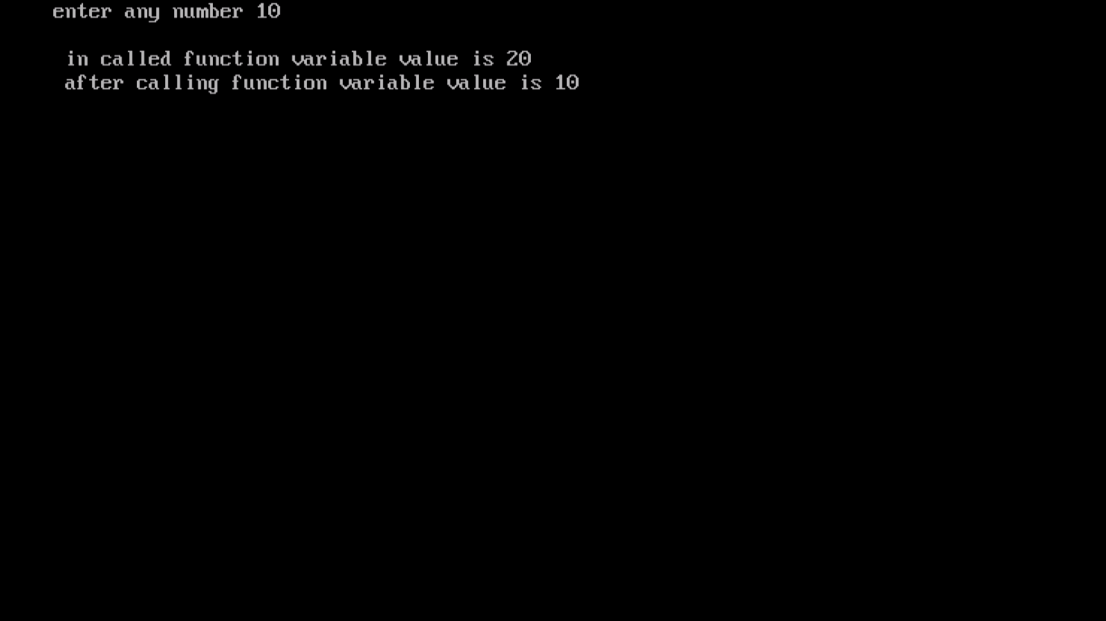

Q.29 write a program demonstrate to call by reference.

Ans.

#include<stdio.h>

#include<conio.h>

void add(int *a);

void main()

{

int x;

printf(“enter any number”);

scanf(“%d”,&x);

add(&x);

printf(“\n after calling function variable value is %d”,x);

getch();

}

Void add(int *a)

{

*a=*a+10;

printf(“\n in Called function variable value is %d”,*a);

}

Output:-

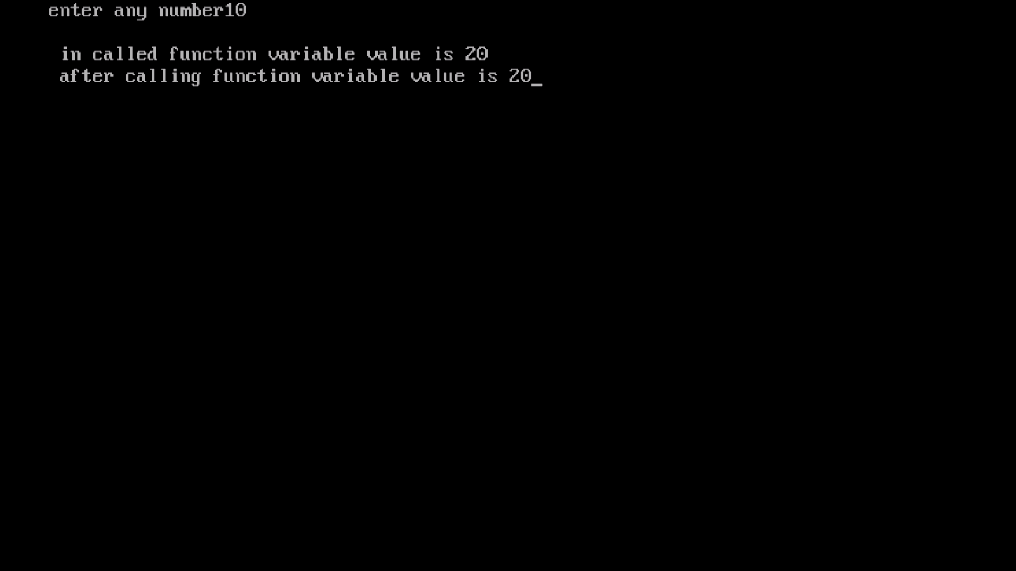

Q.30 Write a program using switch case to calculate the area of circle,square and rectangle.

Ans.

#include<stdio.h>

#include<conio.h>

int main()

{

int n;

float rad,area,nsq,length,breadth;

printf("enter any number\n");

scanf("%d",&n);

switch(n)

{

case 1:

printf("\nplease enter the radius of the circle\n");

scanf("%f",&rad);

area=3.14*rad*rad;

printf("\nArea of circle: %f",area);

break;

case 2:

printf("please enter the lenght of side of the square:");

scanf("%f",&nsq);

area=nsq*nsq;

printf("\nArea of rectangle: %f",area);

break;

case 3:

printf("please enter the lenght of the rectangle:");

scanf("%f",&length);

printf("enter the breadth of the rectangle:");

scanf("%f",&breadth);

area=length*breadth;

printf("\nArea of rectangle: %f",area);

break;

default:

printf("invalid choice");

}

}

Output:-

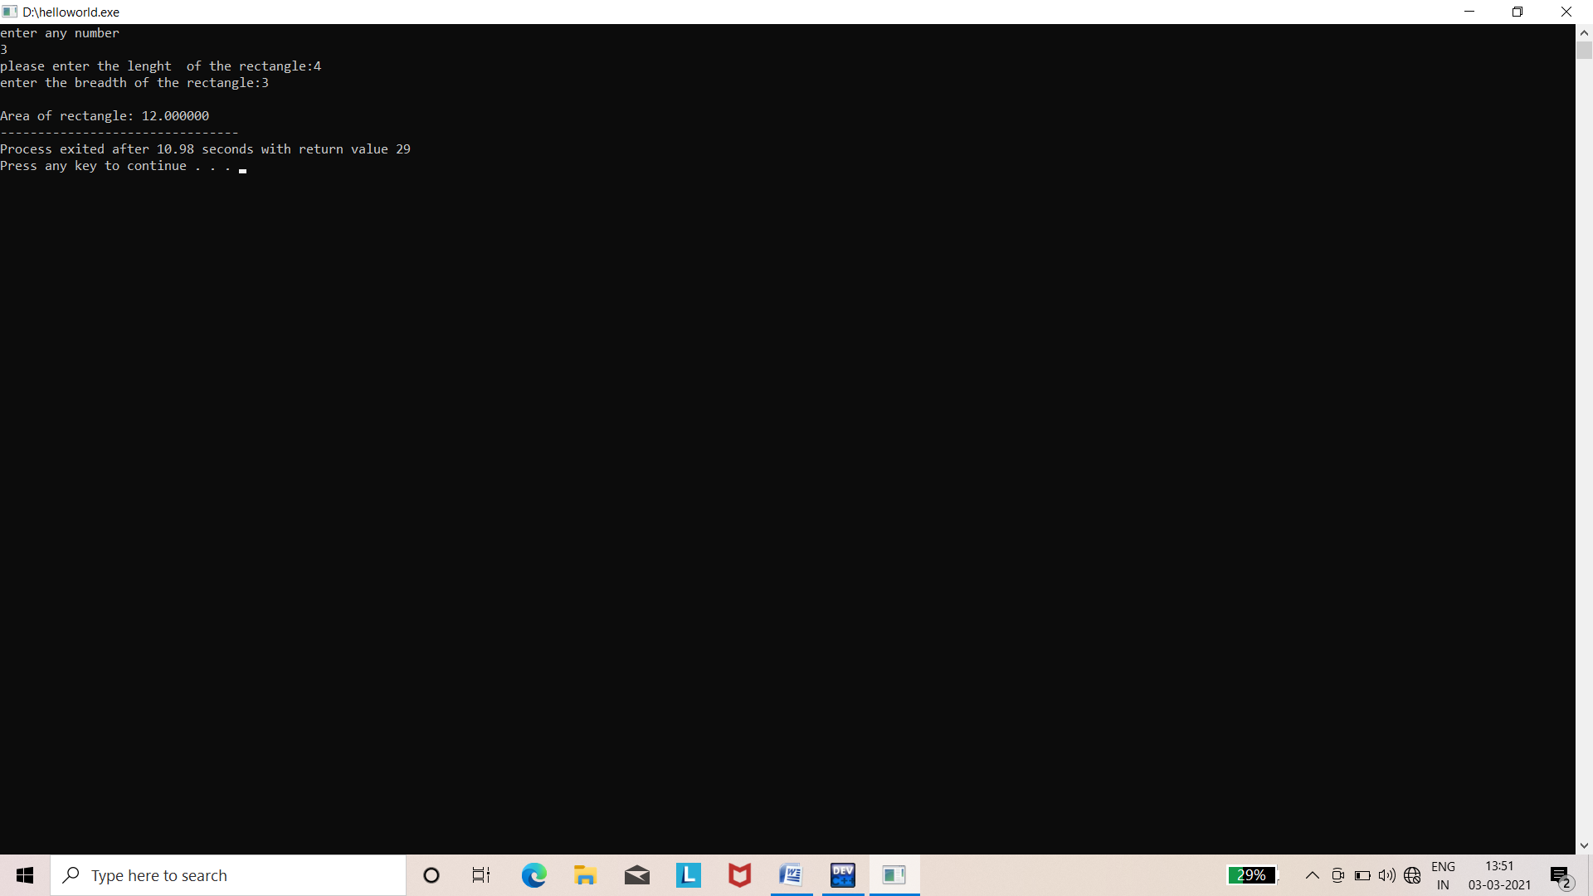

Q.31 write program in c to calculate volume using function.

Ans.

#include<stdio.h>

#include<conio.h>

float pi=3.14;

int cube(int a);

int cuboid(int l,int w,int h);

int sphere(int r);

void main()

{

int i,j,k,l,d,V;

printf("Find volume of some shapes\n");

printf("\n CUBE\n");

cube(i);

printf("\n CUBOID\n");

cuboid(j,k,l);

printf("\n SPHERE\n");

sphere(d);

}

int cube(int a)

{

printf("Enter side of the cube\n");

scanf("%d",&a);

printf("Volume of cube is: %d\n",a*a*a);

return 0;

}

int cuboid(int l,int w,int h)

{

printf("Enter length of cuboid\n");

scanf("%d%d%d",&l,&w,&h);

printf("Volume is cuboid: %d\n",l*w*h);

return 0;

}

int sphere(int r)

{

printf("Enter radius of sphere\n");

scanf("%d",&r);

printf("Volum of sphere is:%f",4/3*pi*r*r*r);

return 0;

}

Output:-

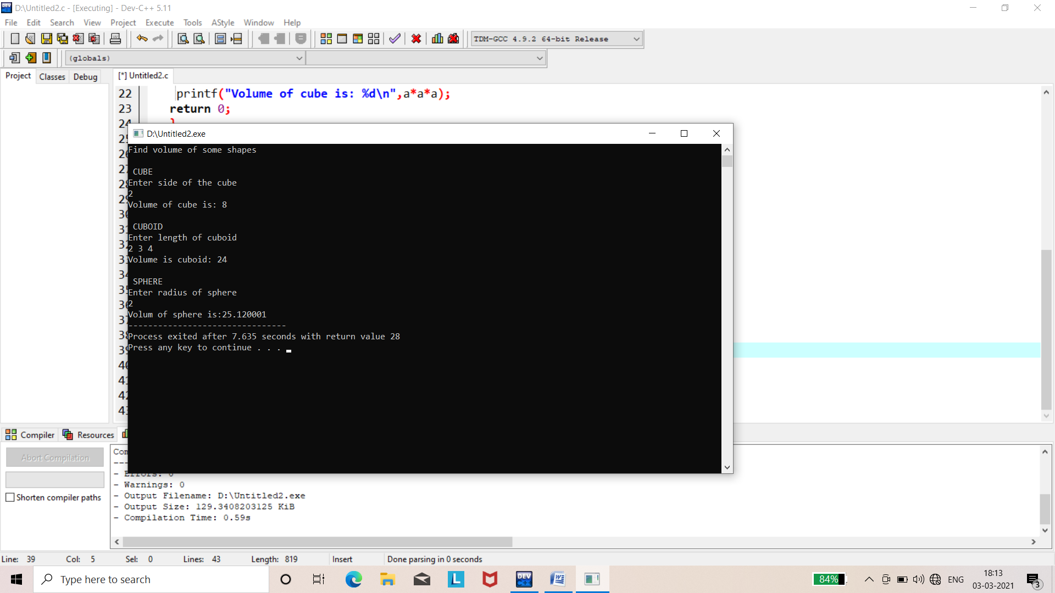

Q.32 Write a program in c to search an element form array by linear serach method.

Ans.

#include<stdio.h>

#include<conio.h>

void main()

{

int i,n,search,count=0;

printf("\n\t Enter number of element in array");

scanf("%d",&n);

int arr[n];

printf("\n\t Enter %d number",n);

for(i=0;i<n;i++)

{

scanf("%d",&arr[i]);

}

printf("\n\t Enter a number to search");

scanf("%d",&search);

for(i=0;i<n;i++)

{

if(arr[i]==search)

{

printf("\n\t %d present at location %d",search,(i+1));

count++;

}

}

if(count==0)

{

printf("\n\t %d is not present in array ",search);

}

else

{

printf("\n\t %d is present %d times in array",search,count);

}

}

Output:-

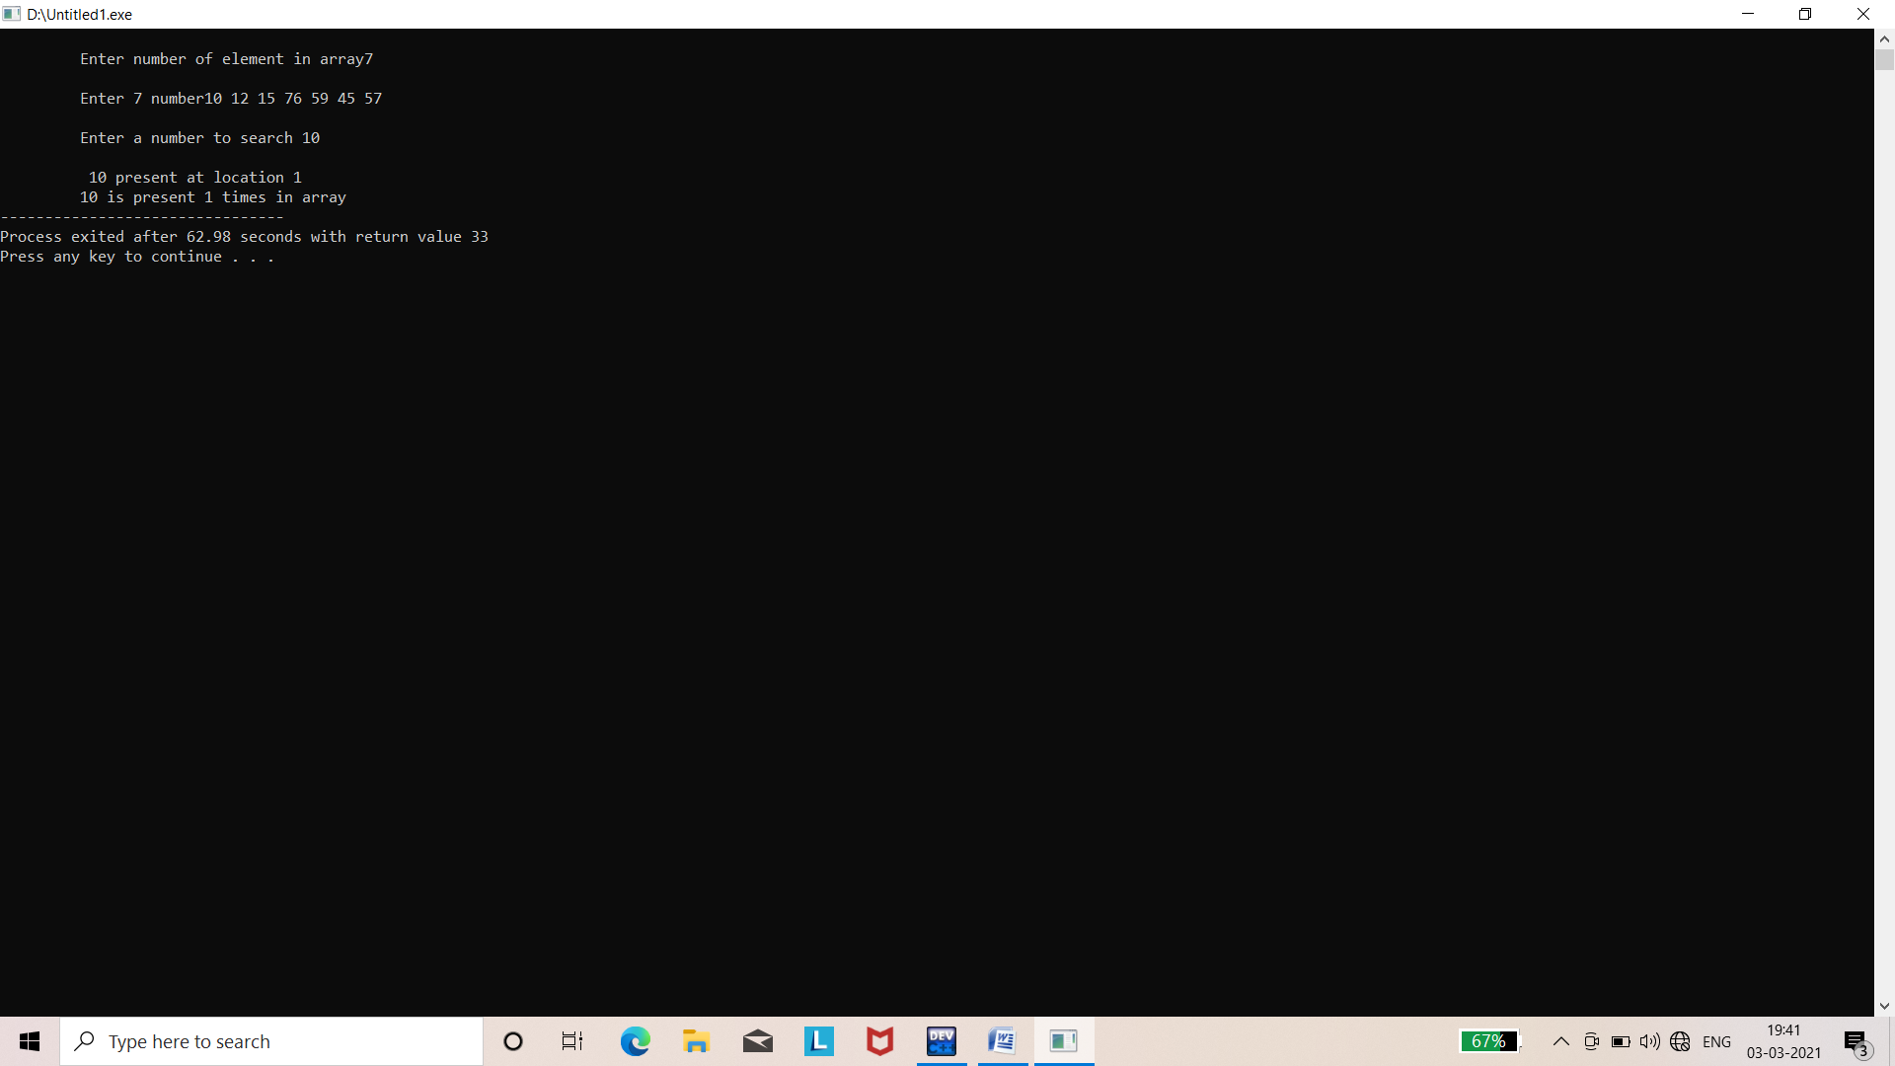

Q.33 Write a program to find transpose of matrix.

Ans.

#include<stdio.h>

#include<conio.h>

void main()

{

int a[2][2],i,j,m,n;

printf("number of rows\n");

scanf("%d",&m);

printf("number of columns\n");

scanf("%d",&n);

printf("Enter element of matrix\n");

for(i=0;i<m;i++)

{

for(j=0;j<n;j++)

{

scanf("%d",&a[i][j]);

}

}

printf("Matrix is \n");

for(i=0;i<m;i++)

{

for(j=0;j<n;j++)

{

printf("%d\t",a[i][j]);

}

printf("\n");

}

printf("Transpose of matrix\n");

for(i=0;i<m;i++)

{

for(j=0;j<n;j++)

{

printf("%d\t",a[j][i]);

}

printf("\n");

}

}

Output:-

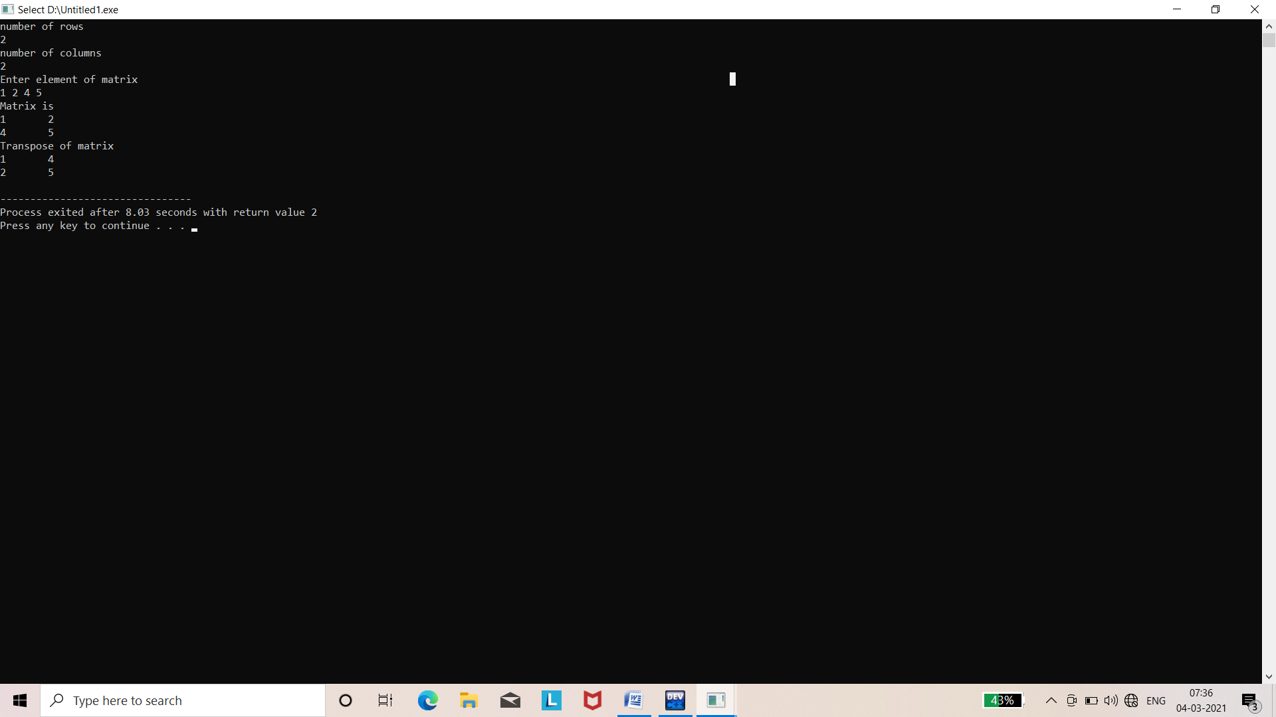

Q.34 Write a program to input a string and find it’s length without using library function.

Ans.

#include<stdio.h>

#include<conio.h>

void main()

{

char a[15];

int i,l=0;

printf("\n enter the string :");

scanf("%s",a);

for(i=0;a[i]!='\0';i++)

l++;

printf("\n length=%d",l);

getch ();

}

Output:-

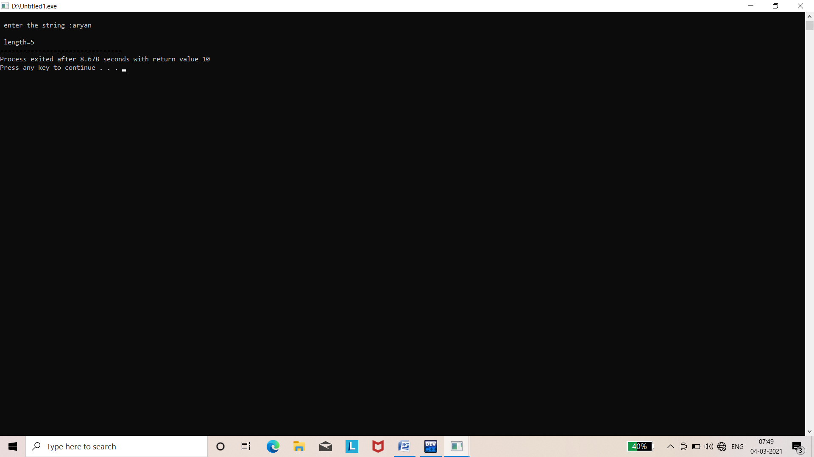

Q.35 write program to check whether the enter string palindrome or not.

Ans.

#include<stdio.h>

#include<conio.h>

#include<string.h>

int main()

{

char str[50];

int i,len,flag=0;

printf("\n Enter the string to check for palindrome");

scanf("%s",str);

len=strlen(str);

for(i=0;i<len;i++)

{

if(str[i]!=str[len-i-1])

{

flag=1;

break;

}

}

if (flag==0)

printf("string is palindrome");

else

printf("string is not a palindrome");

getch();

return 0;

}

Output:-

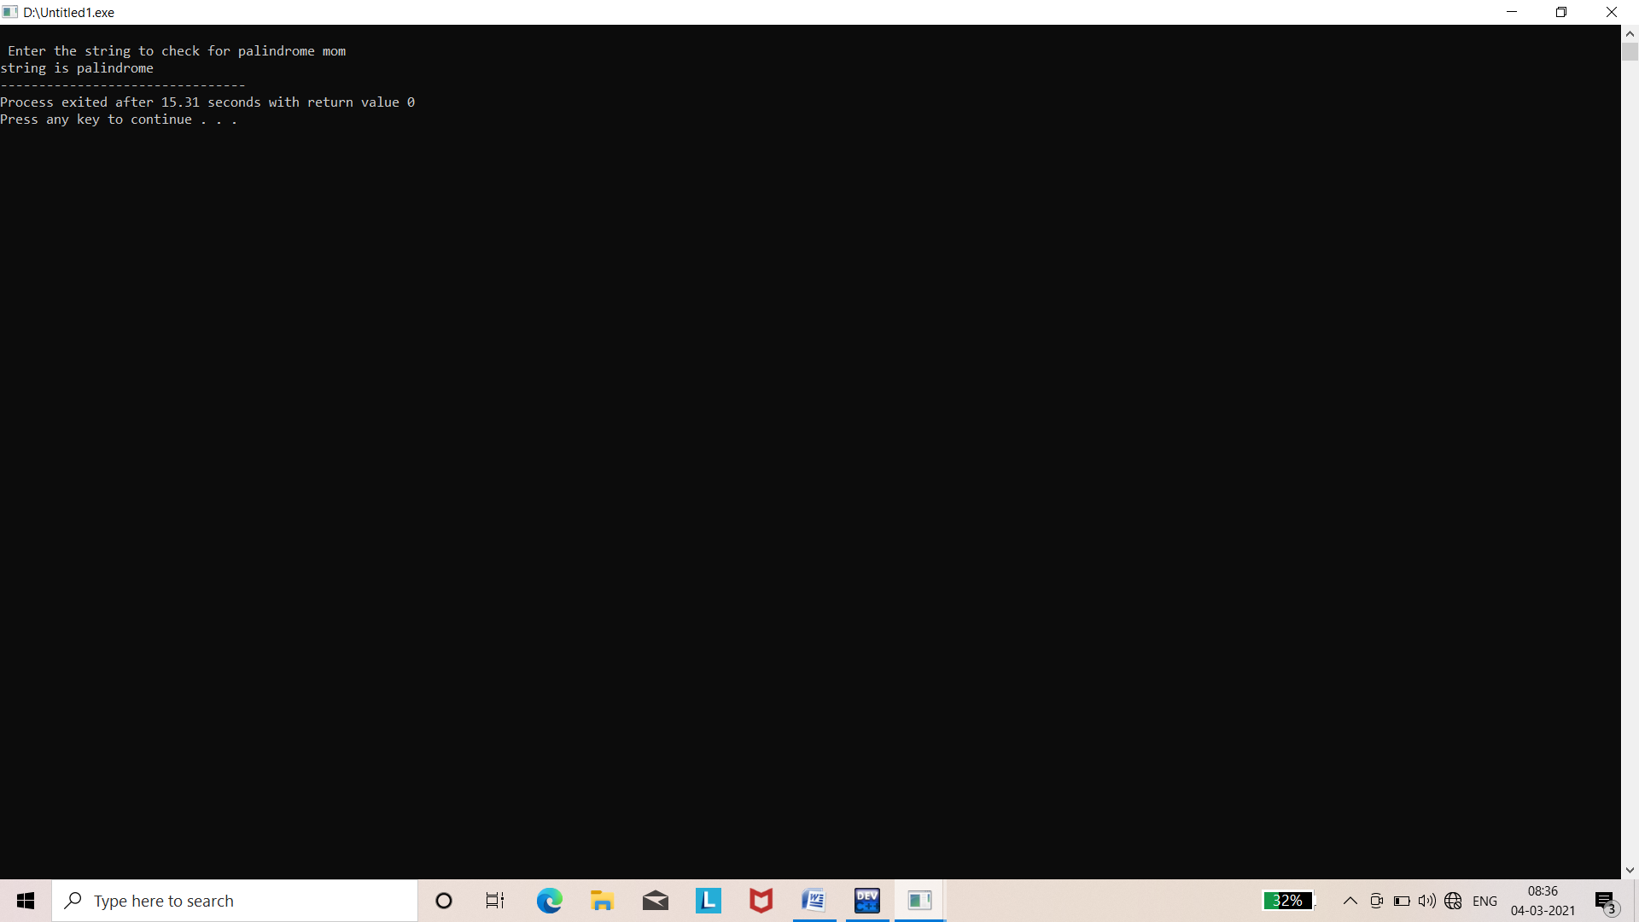

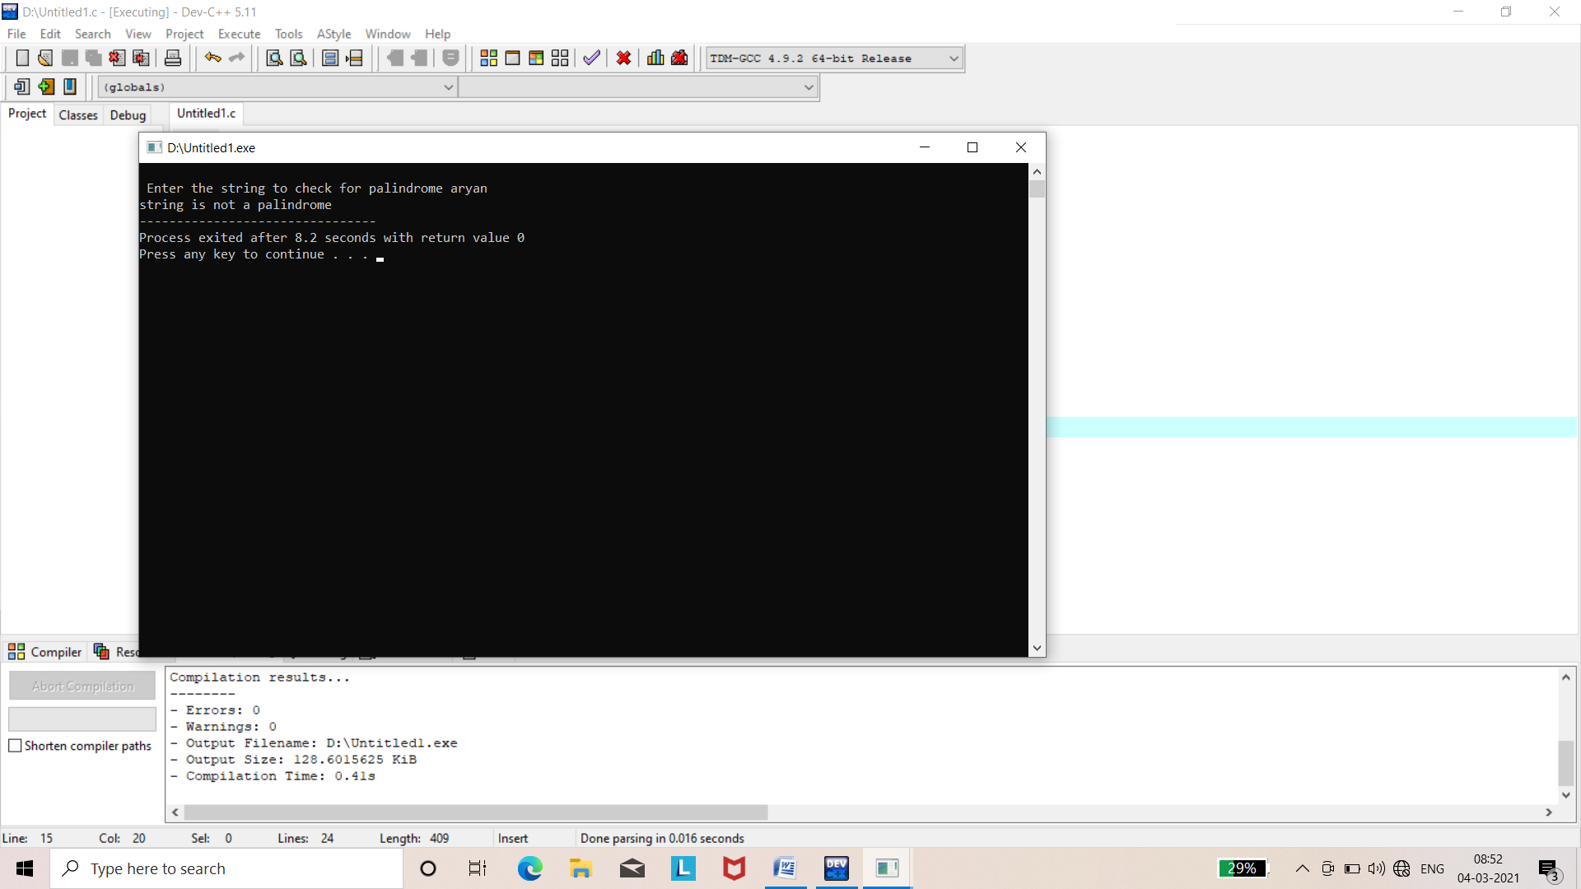

Q.36 Write a program to calculate reverse string and length string help with library function.

Ans.

#include<stdio.h>

#include<conio.h>

#include<string.h>

void main()

{

char str[100];

int i;

printf("Enter the string: ");

scanf("%s",str);

printf("Reverse of str is %s\n",strrev(str));

printf("length of sting is %d",strlen(str));

getch();

}

Output:-

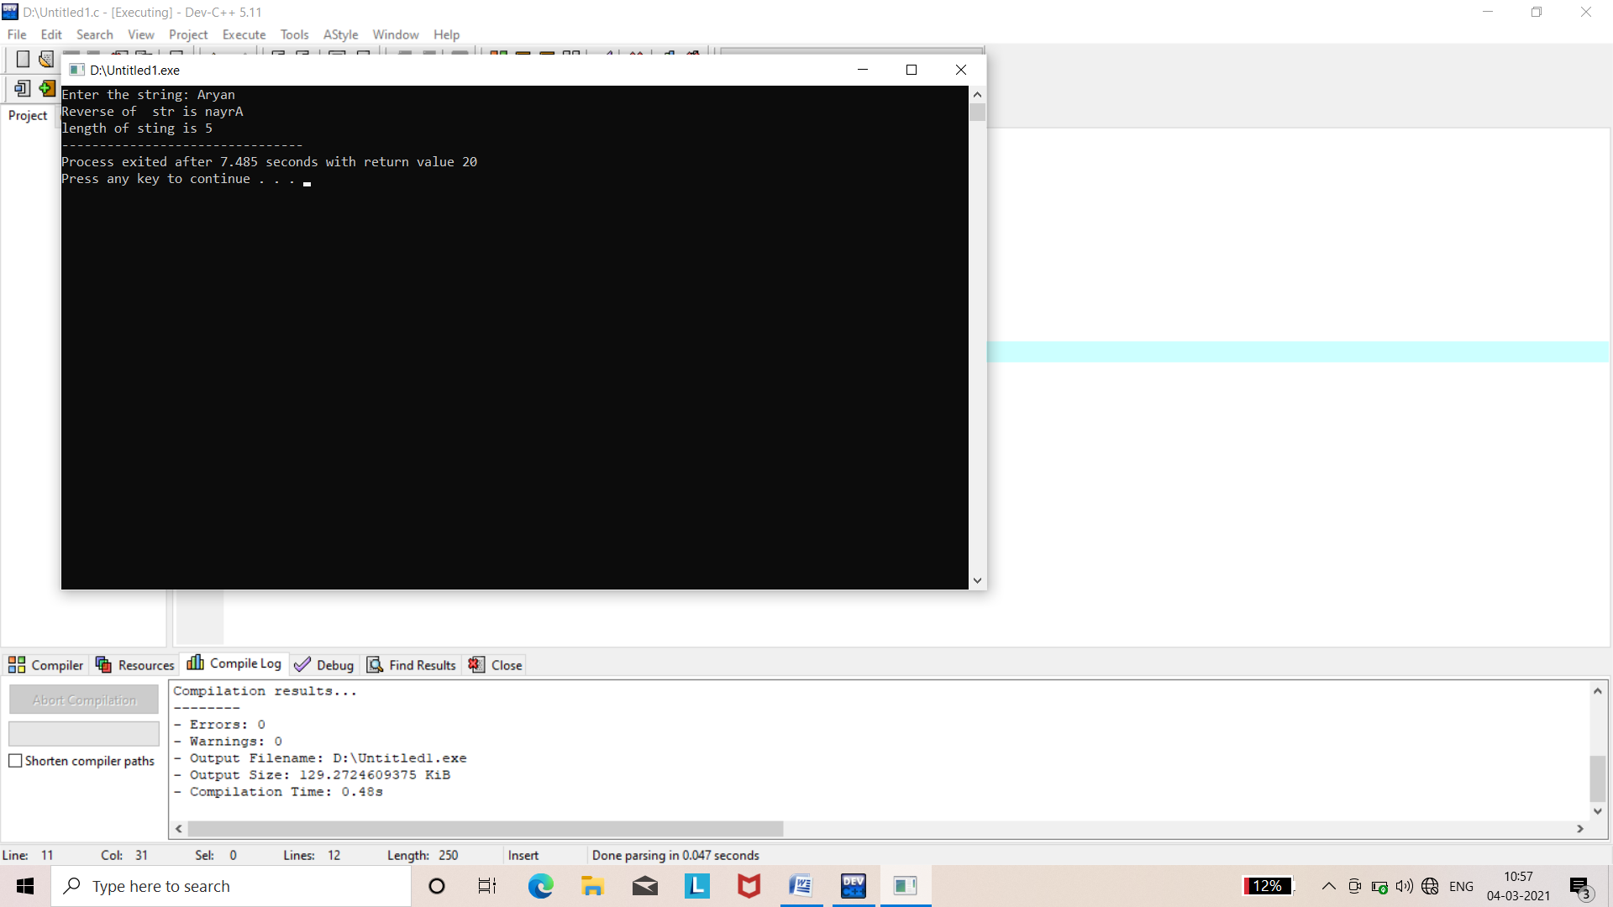

Q.37 Write a program in c to input and print details of an employee the id,name,salary using structure.

Ans.

#include<stdio.h>

#include<conio.h>

struct employee

{

char name[100];

int id;

float salary;

};

void main()

{

struct employee emp;

printf("Enter detials of employee:\n");

printf("Enter employee name:");

scanf("%s",&emp.name);

printf("Enter employee id:");

scanf("%d",&emp.id);

printf("Enter employee salary:");

scanf("%f",&emp.salary);

printf("Detials of employee\n");

printf("Name :%s\n",emp.name);

printf("Id :%d\n",emp.id);

printf("salary:%f\n",emp.salary);

getch();

}

Output:-

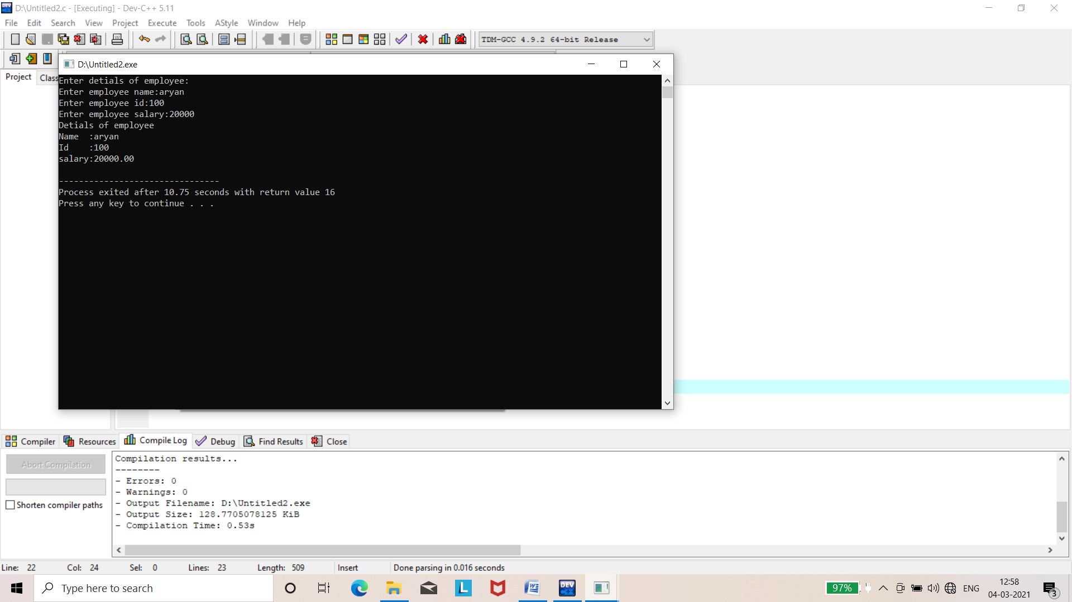

Q.38 Write a program to demonstrate array of structure.

Ans.

#include<stdio.h>

#include<conio.h>

#define MAX 2

struct student

{

char name[20];

int rollno;

float marks;

};

int main()

{

struct student arr_student[MAX];

int i,j;

float sum=0;

for(i=0;i<MAX;i++)

{

printf("\n Enter detials of student %d\n\n",i+1);

printf("Enter name:");

scanf("%s",arr_student[i].name);

printf("Enter roll no.:");

scanf("%d",&arr_student[i].rollno);

printf("Enter marks:");

scanf("%f",&arr_student[i].marks);

}

printf("\n");

printf("Name\t Rollno.\tmarks\n\n");

for(i=0;i<MAX;i++)

{

printf("%s\t%d\t%.2f\n",arr_student[i].name,arr_student[i].rollno,arr_student[i].marks);

}

return 0;

}

Output:-

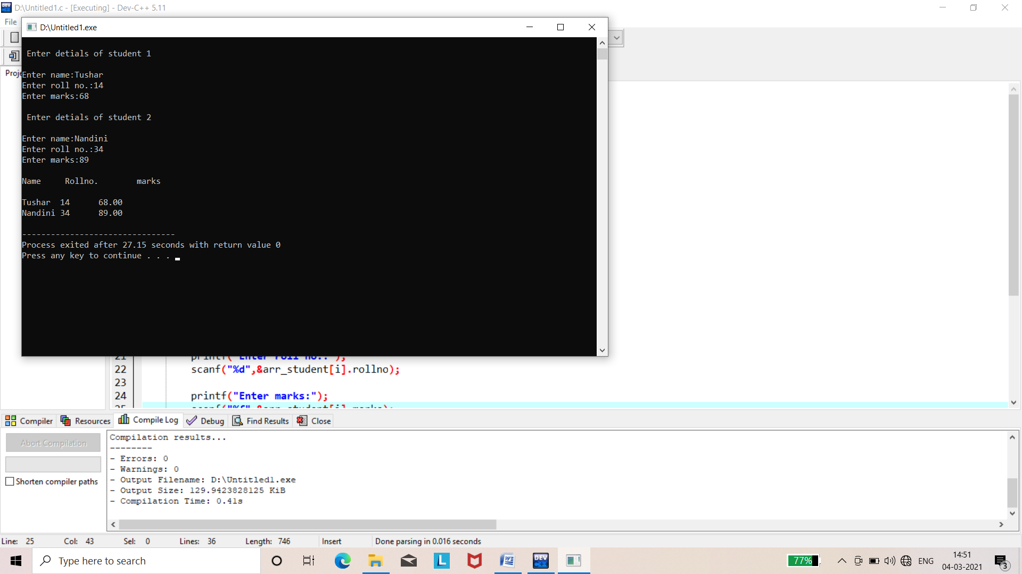

Q.39 Write a program in c to demonstrate pointer to a pointer(double pointer).

Ans.

#include<stdio.h>

#include<conio.h>

int main()

{

int a=10;

int *p;

int **pp;

p=&a; // pointer is pointing to the address of a

pp=&p; // pointer pp is a double pointer pointing to the adress of pointing p

printf("address of a: %x\n"); // adress of a will be printed

printf("address of p: %x\n",pp); // adress of p will be printed

printf("value stored at p: %d\n",*p);

printf("value stord at pp: %d\n",**pp);

getch();

}

Output:-

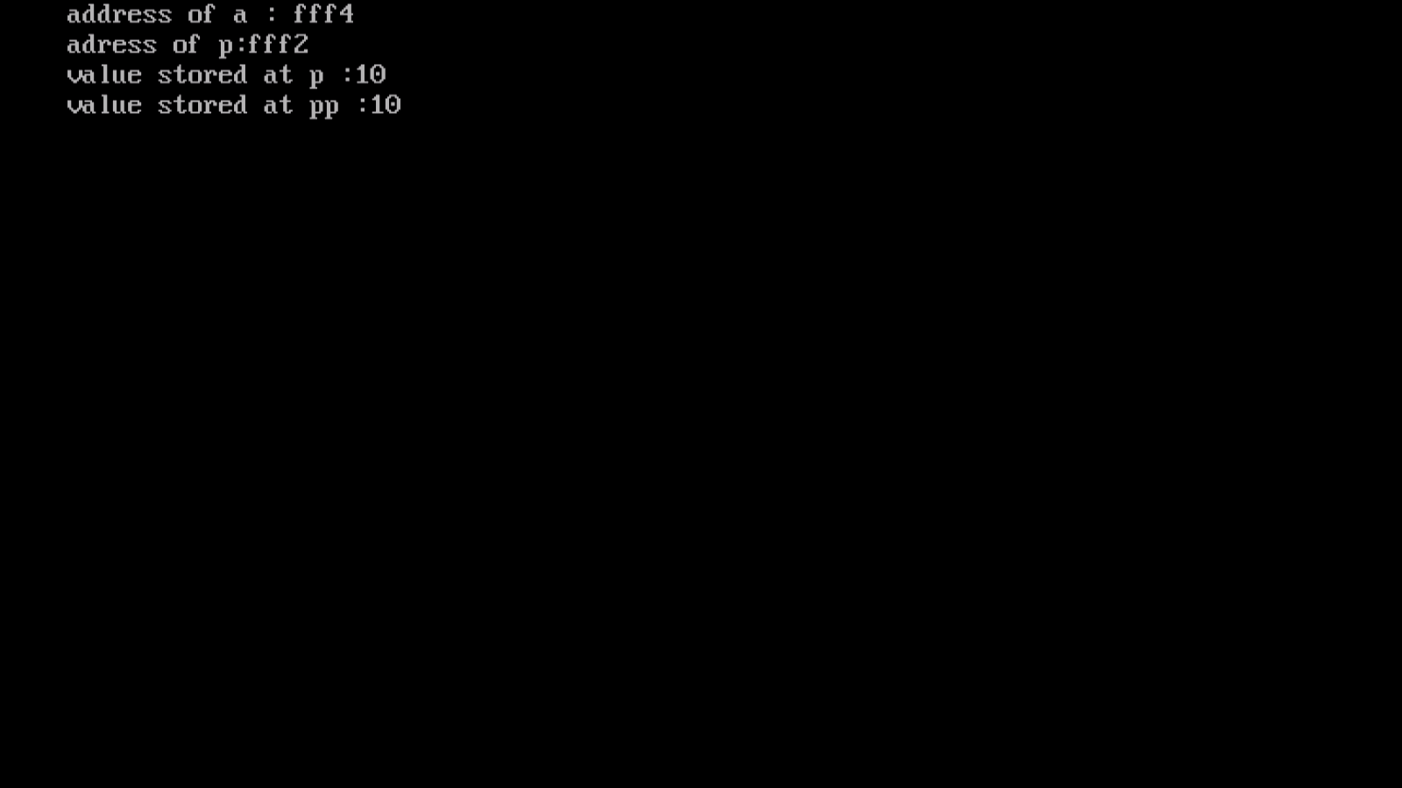

Q.40 Write a program to demonstrate the use of malloc and realloc in.

Ans.

**Code:-**

#include<stdio.h>

#include<stdlib.h>

struct course

{

char subjects[100];

int marks;

};

int main()

{

struct course*ptr;

int i,n;

printf("\nenter the records:");

scanf("%d",&n);

ptr=(struct course*)malloc(n* sizeof(struct course));

for(i=0;i<n;++i)

{

printf("\nenter the %d no of records:",i+1);

printf("\nenter the subjects:");

scanf("%s",&(ptr+i)->subjects);

printf("\nenter the marks:");

scanf("%d",&(ptr+i)->marks);

}

printf("\ndisplayed course record:");

for(i=0;i<n;i++)

{

printf("\nsubjects= %s",(ptr+i)->subjects);

printf("\nmarks= %d",(ptr+i)->marks);

}

printf("\n------------------------------------------------------");

printf("\nenter the new records you want to create:");

scanf("%d",&n);

ptr=(struct course*)realloc(ptr,n* sizeof(struct course));

for(i=0;i<n;i++)

{

printf("\nenter the %d no of records:",i+1);

printf("\nenter the subjects:");

scanf("%s",&(ptr+i)->subjects);

printf("\nenter the marks:");

scanf("%d",&(ptr+i)->marks);

}

printf("\ndisplayed course record:");

for(i=0;i<n;i++)

{

printf("\nsubjects=%s",(ptr+i)->subjects);

printf("\nmarks=%d",(ptr+i)->marks);

}

return 0;

}

**Output:-**

